

PROJECT 1 -2024

Arabi Flower



May 30, 2024

lebanese University – FACULTY OF SCIENCE

LEBANON - FANAR

Table of Contents

1. Setup an account on any cloud provider 2

2. Version Control 2

a. Create a GitHub repository for the sample web application. 2

b. Clone the repository to your local development environment. 3

c. Create a basic web application (HTML, CSS, JavaScript) and add it to the repository. 3

d. Commit and push the code to the GitHub repository. 4

e. The Website 5

3. Continuous Integration (CI) And Containerization: 6

a. Set up a CI/CD service. 6

i. Creating the project. 6

ii. Creating a pipeline for ci: 7

iii. Requesting Hosted paralleliosm: 9

b. Creating account on docker hub to store images: 10

i. Creating a repo on docker hub 10

ii. Adding a DOCKERFILE to the repository 11

c. Creating a service connection to the docker hub: 12

d. Configuring the pipeline: 14

e. TESTING: 15

i. Push an update: 15

ii. Checking the pipeline 15

iii. Checking the repos on docker hub: 16

4. Continuous Deployment (CD) 16

a. Creating a WebApp resource to host the application 16

b. Creating Pipeline to automate CD: 17

c. TESTING: 19

# Setup an account on any cloud provider

We are using **Microsoft Azure** as a cloud provider.

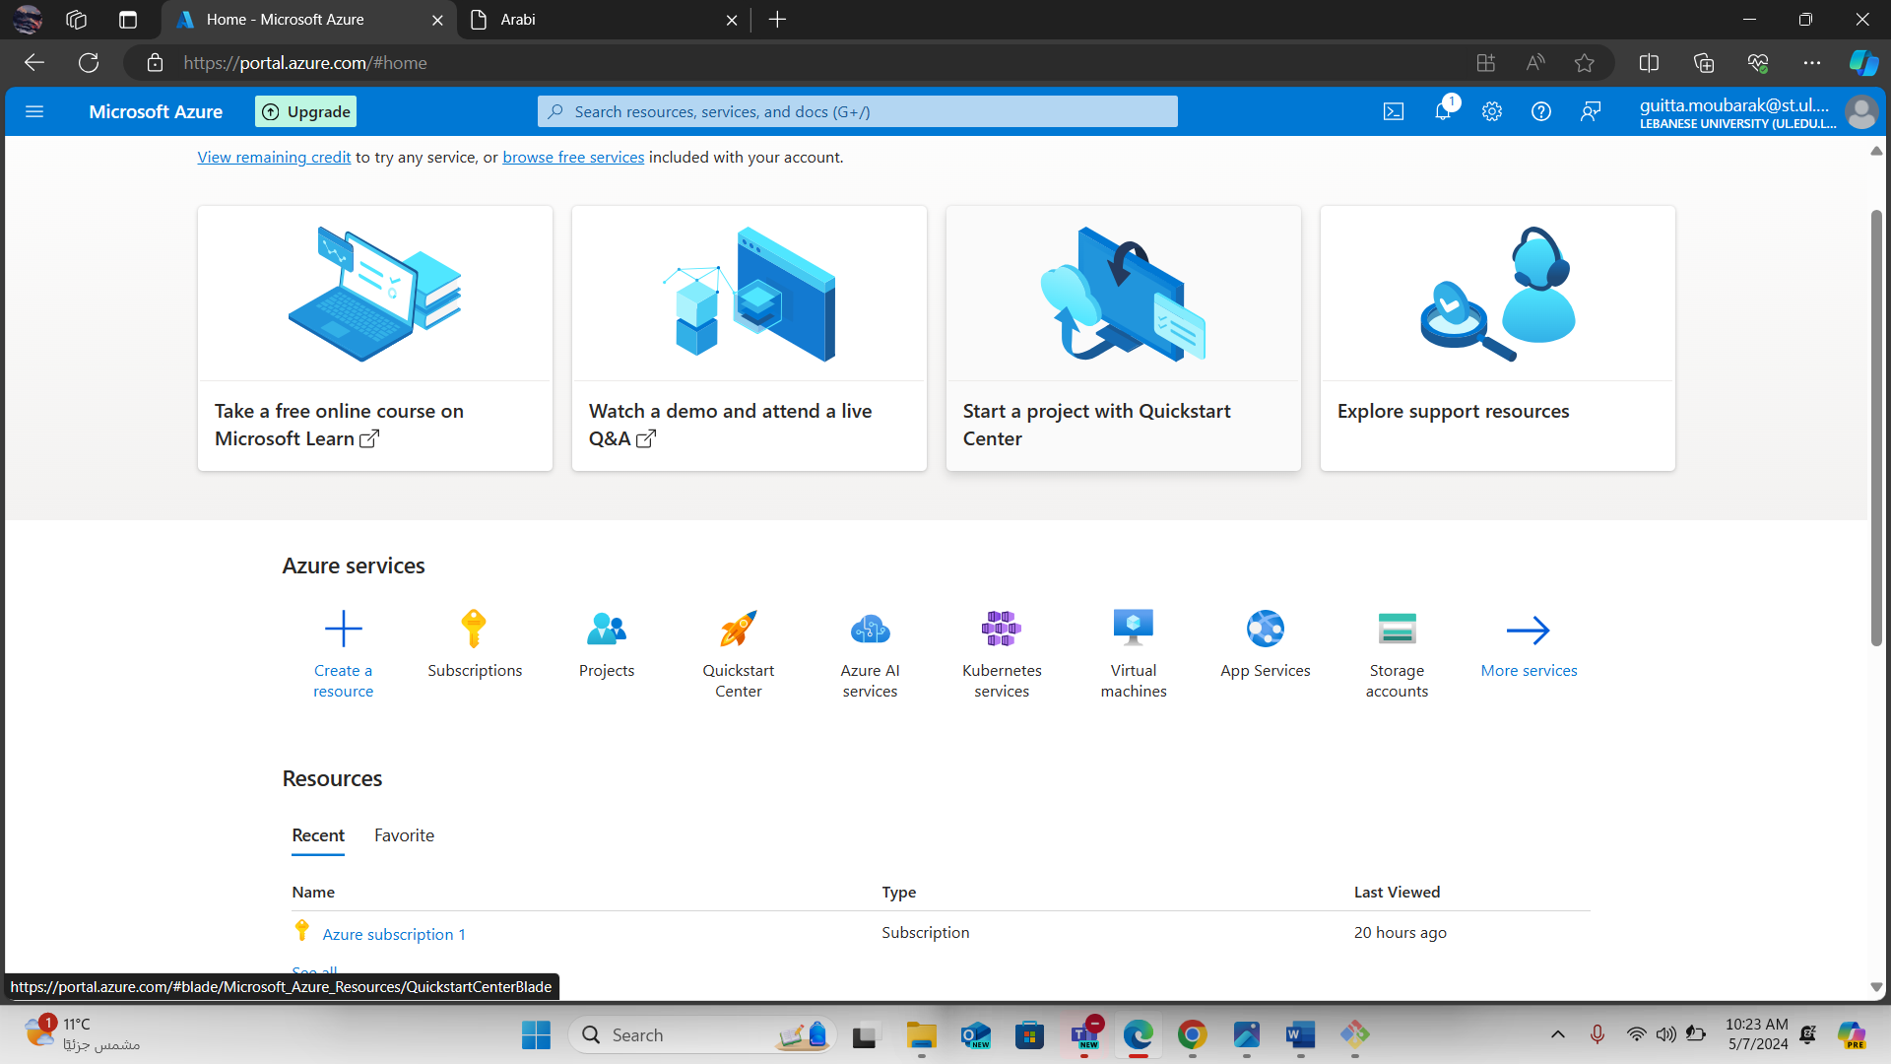

# Version Control

## Create a GitHub repository for the sample web application.

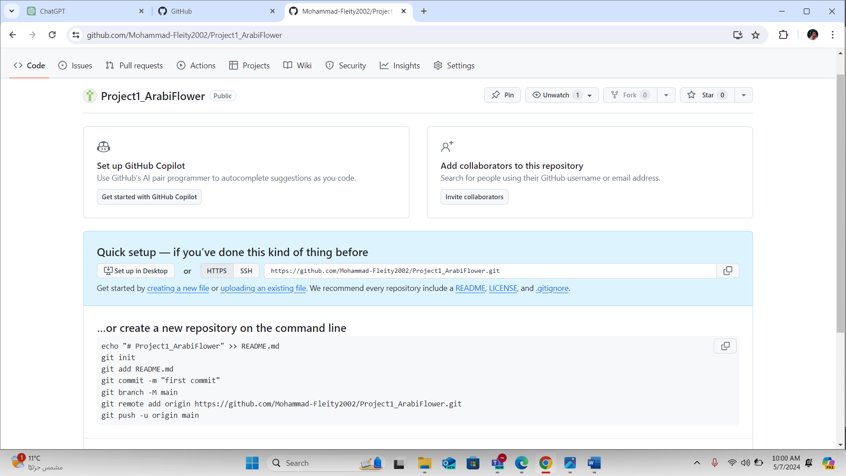

## Clone the repository to your local development environment.

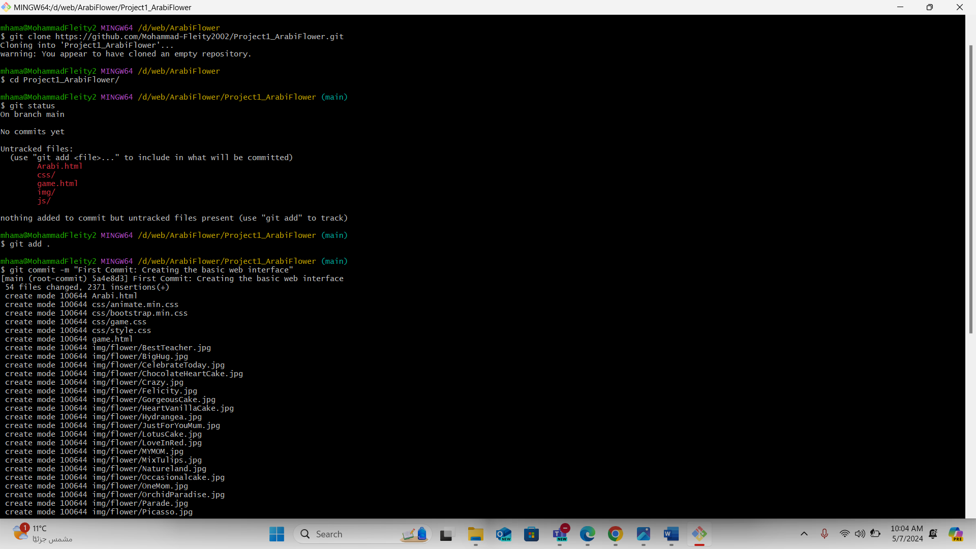

## Create a basic web application (HTML, CSS, JavaScript) and add it to the repository.

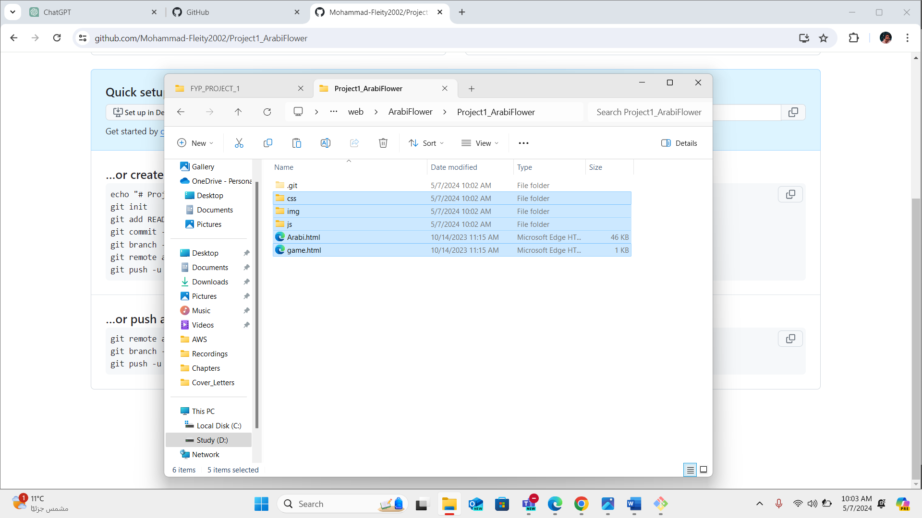

## Commit and push the code to the GitHub repository.

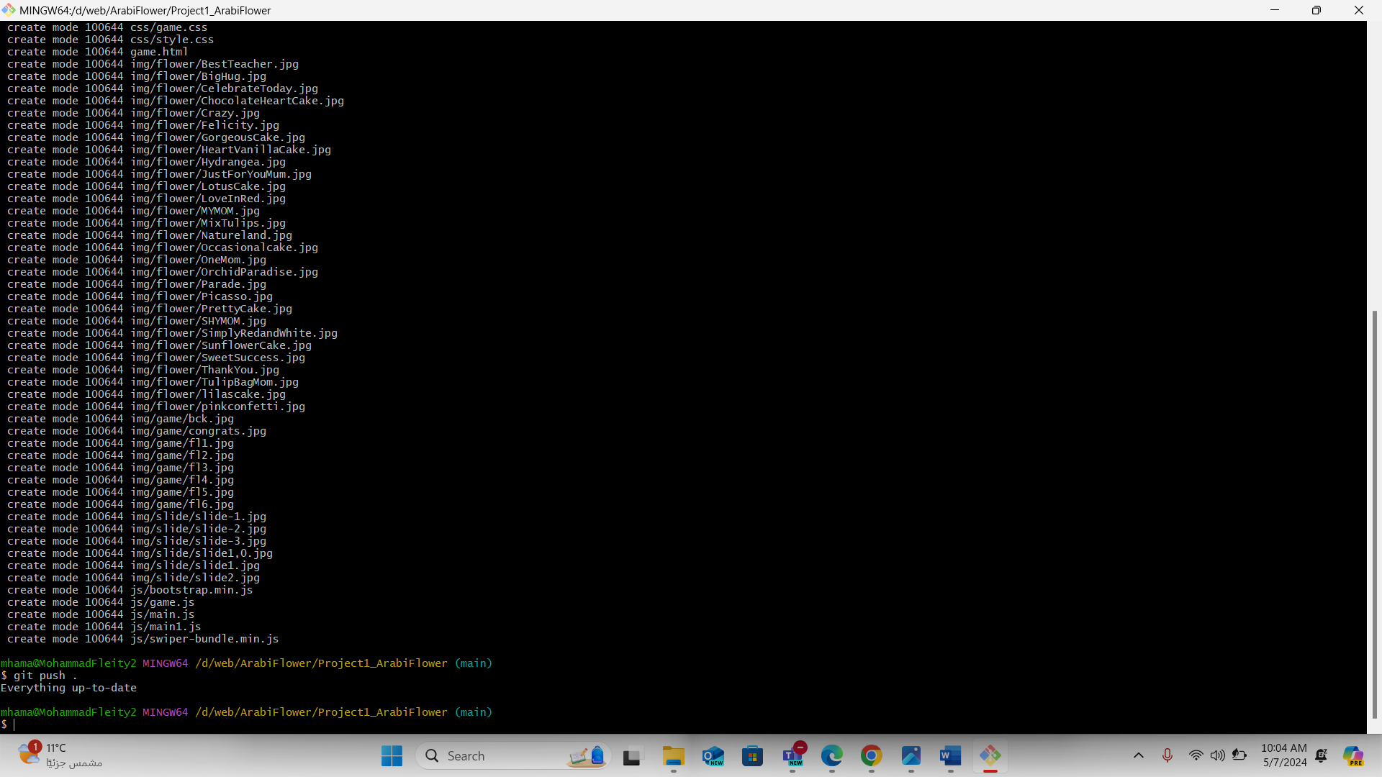

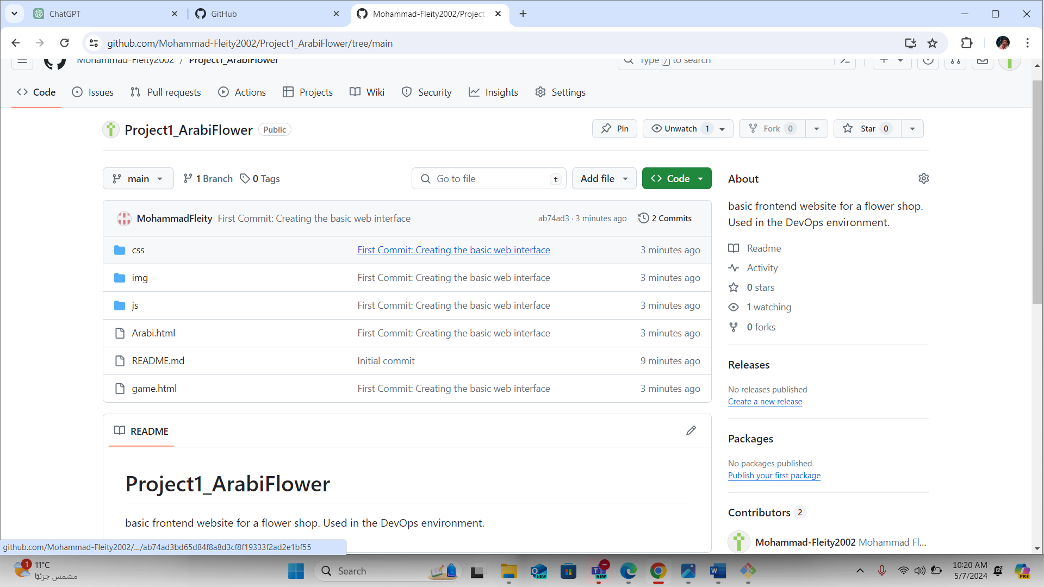

## The Website

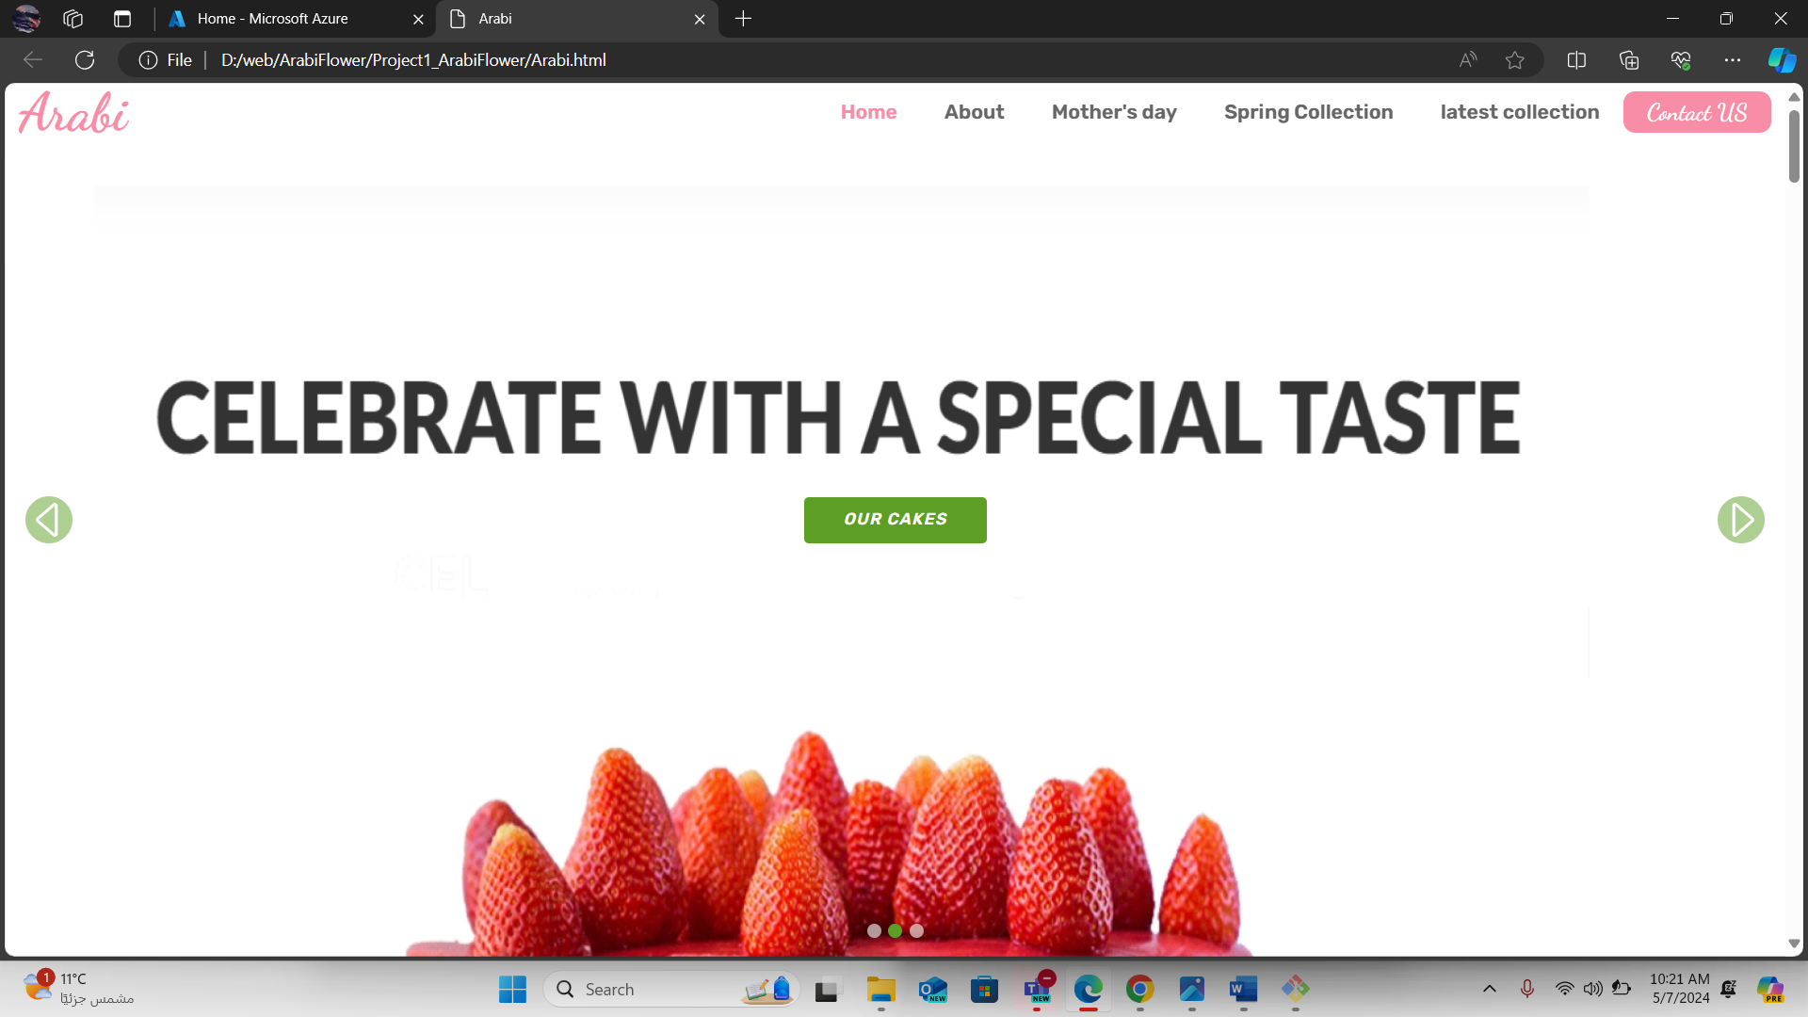

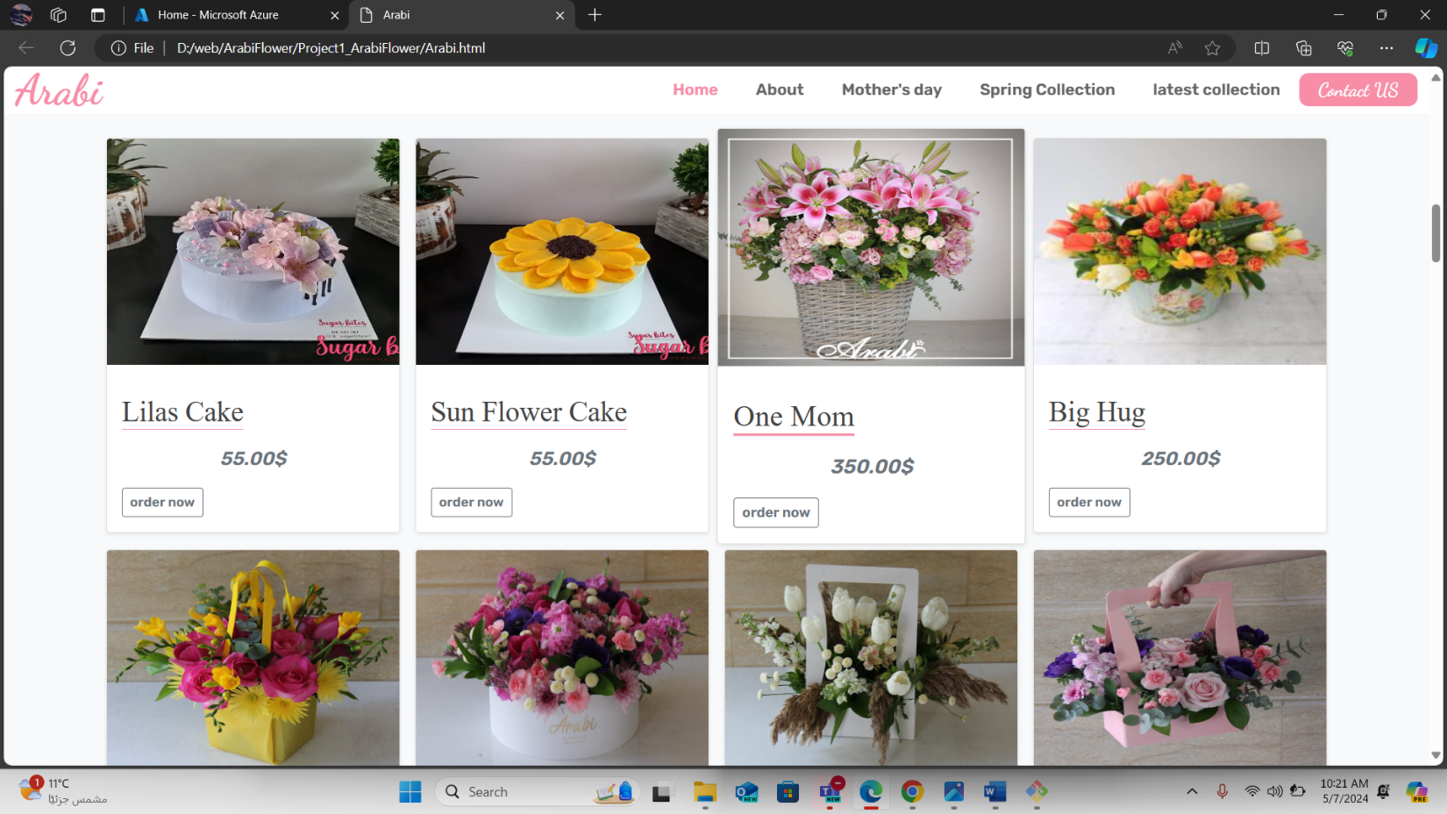

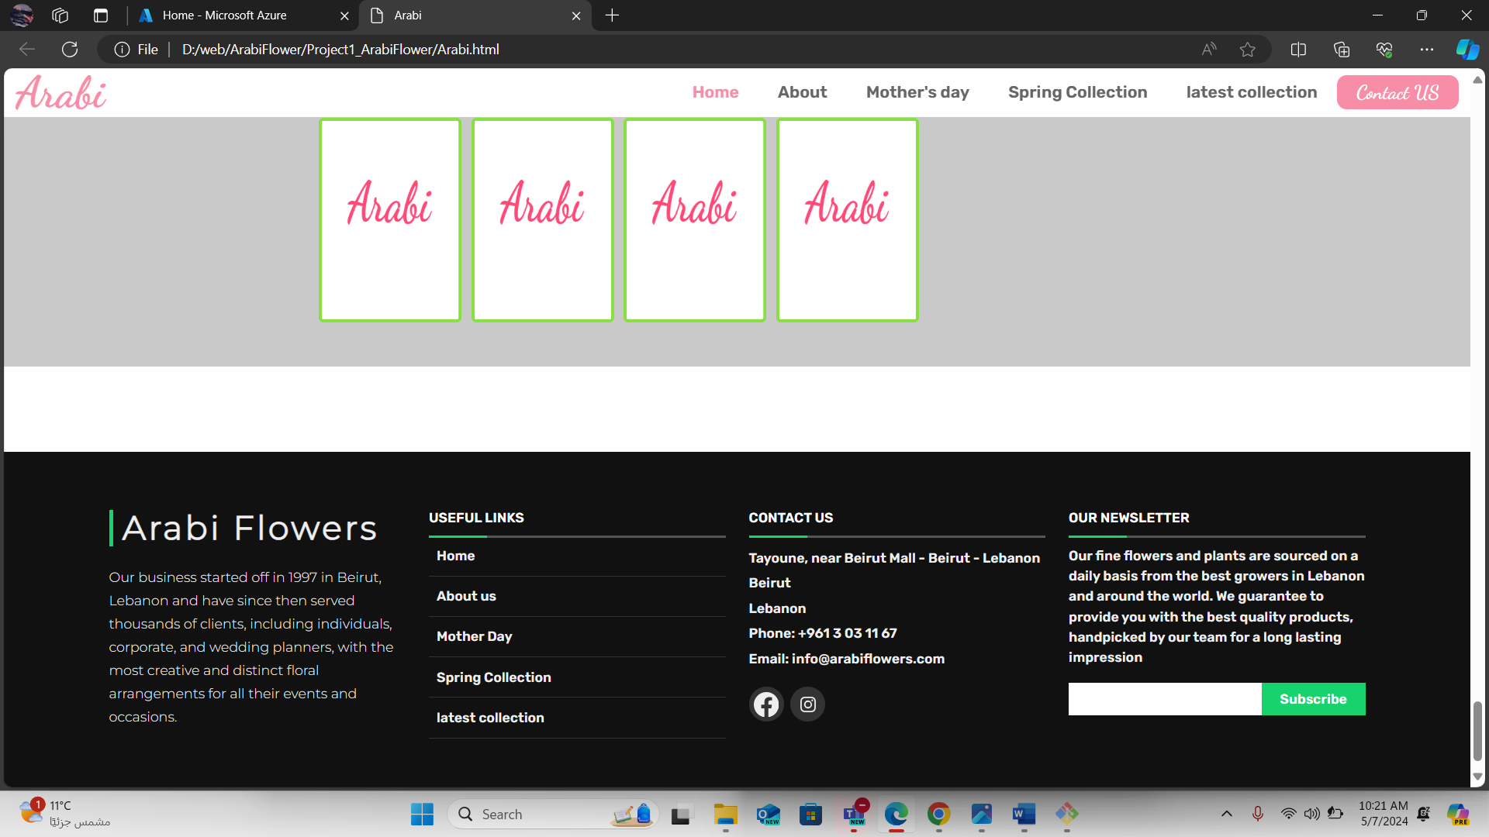

# Continuous Integration (CI) And Containerization:

## Set up a CI/CD service.

### Creating the project.

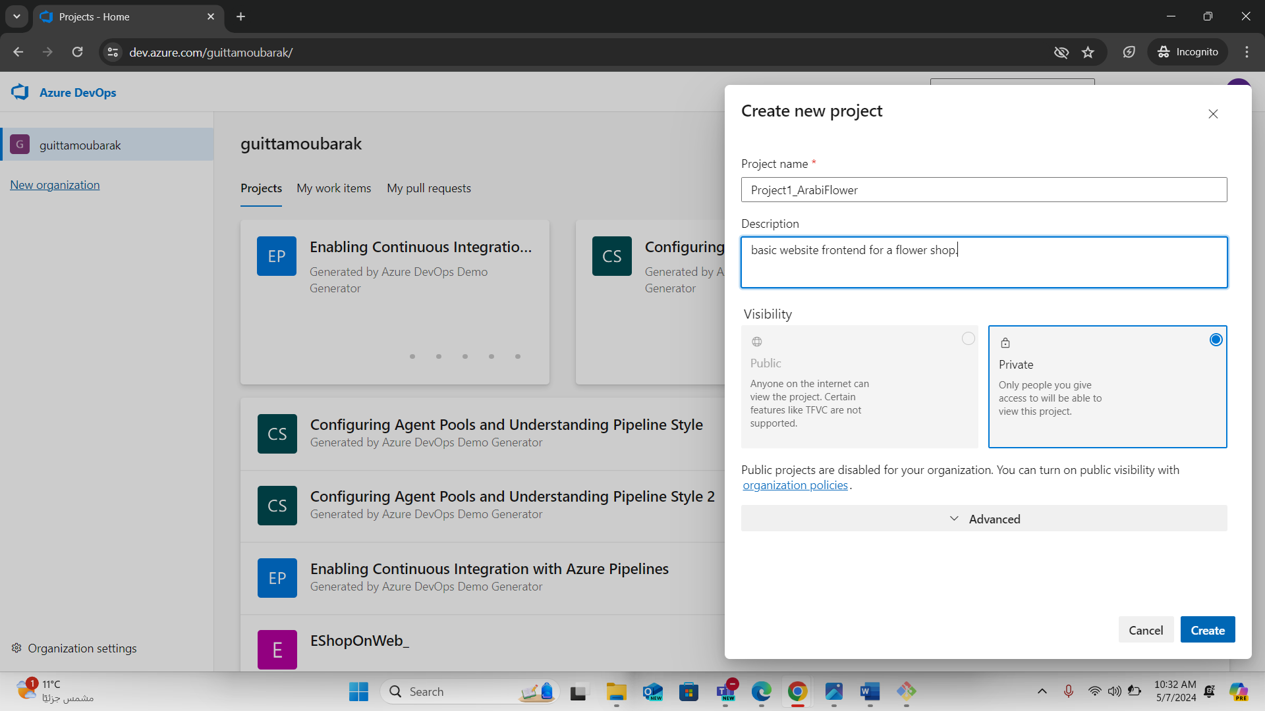

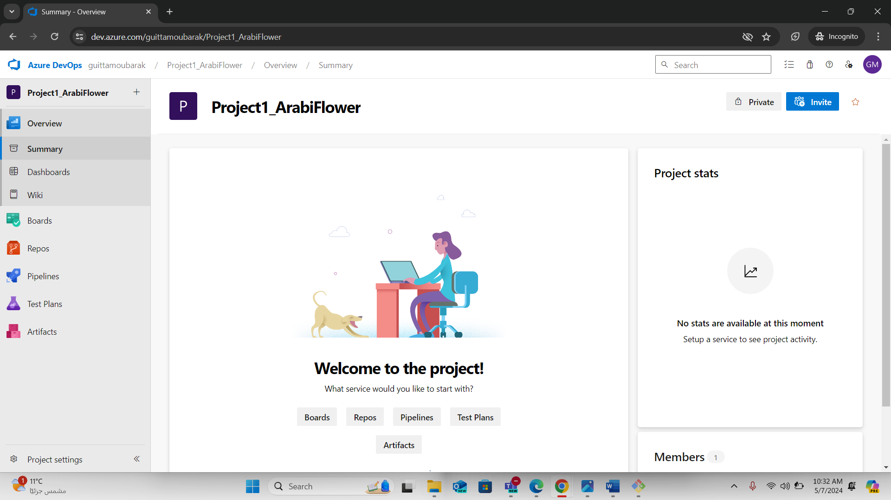

### Creating a pipeline for ci:

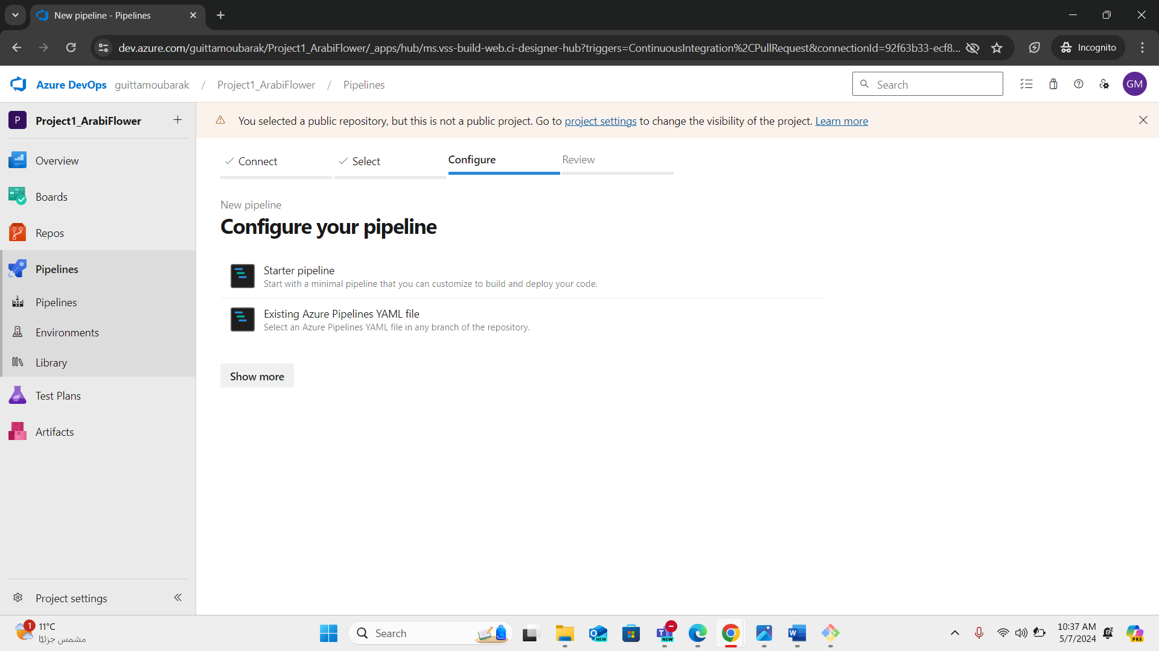

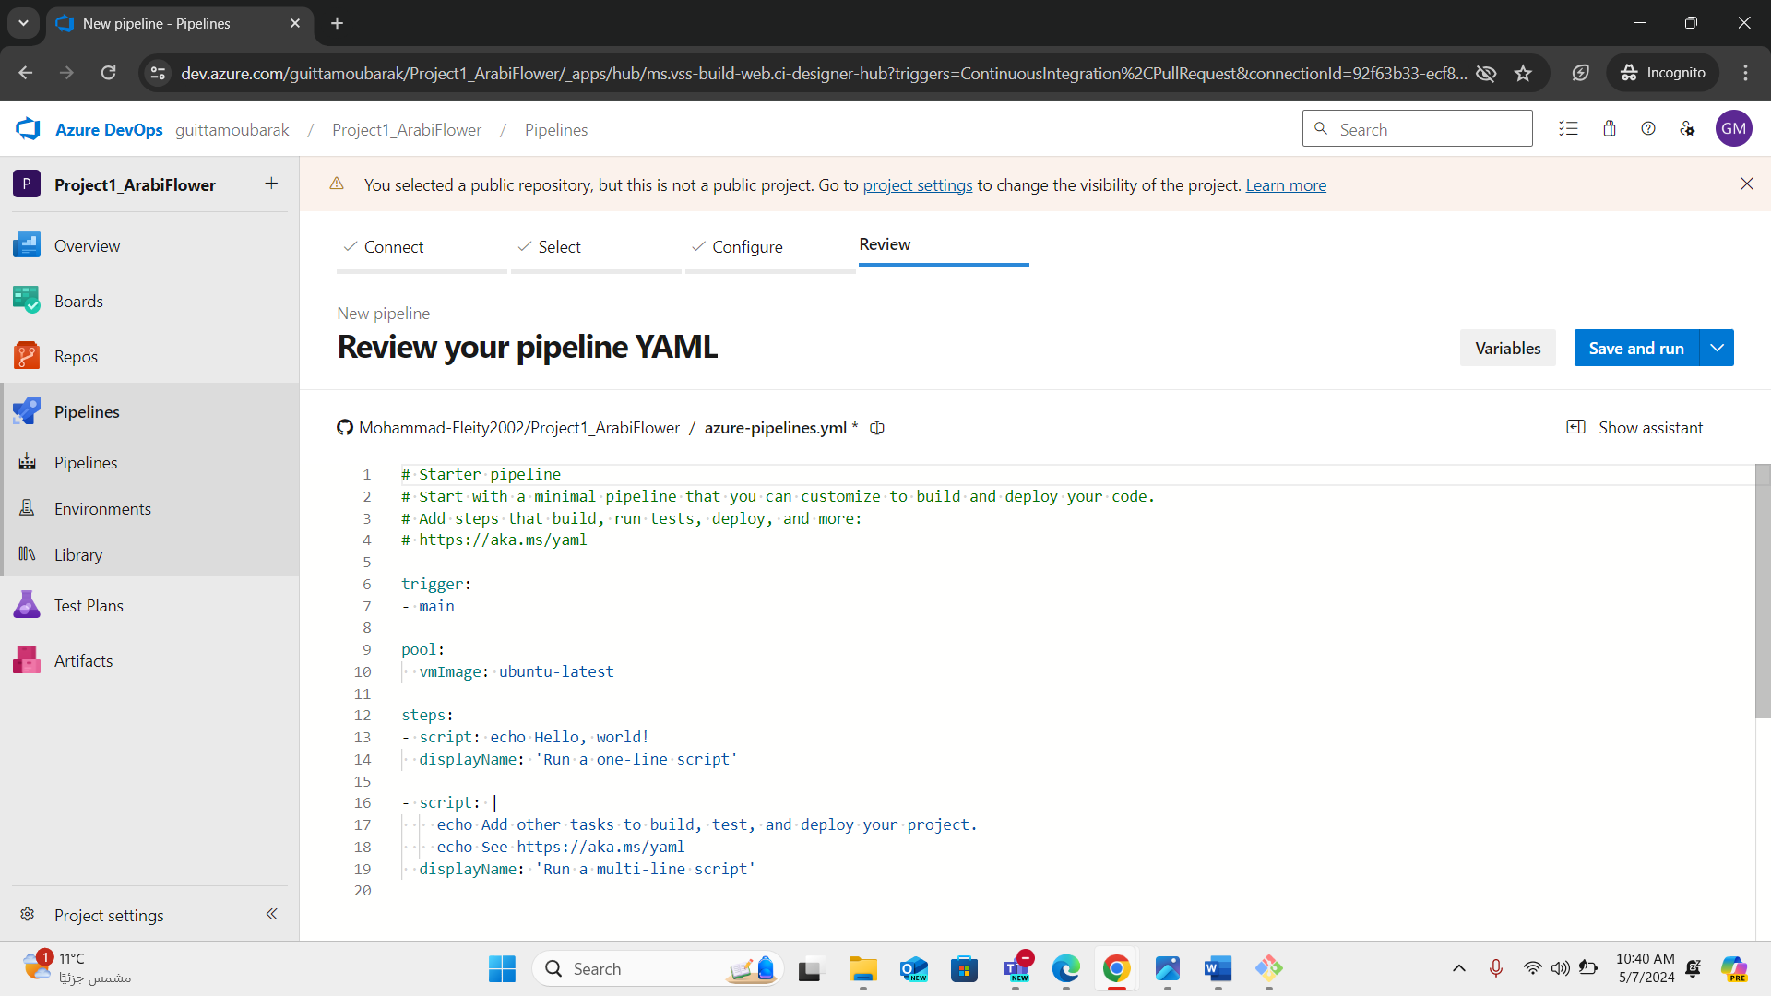

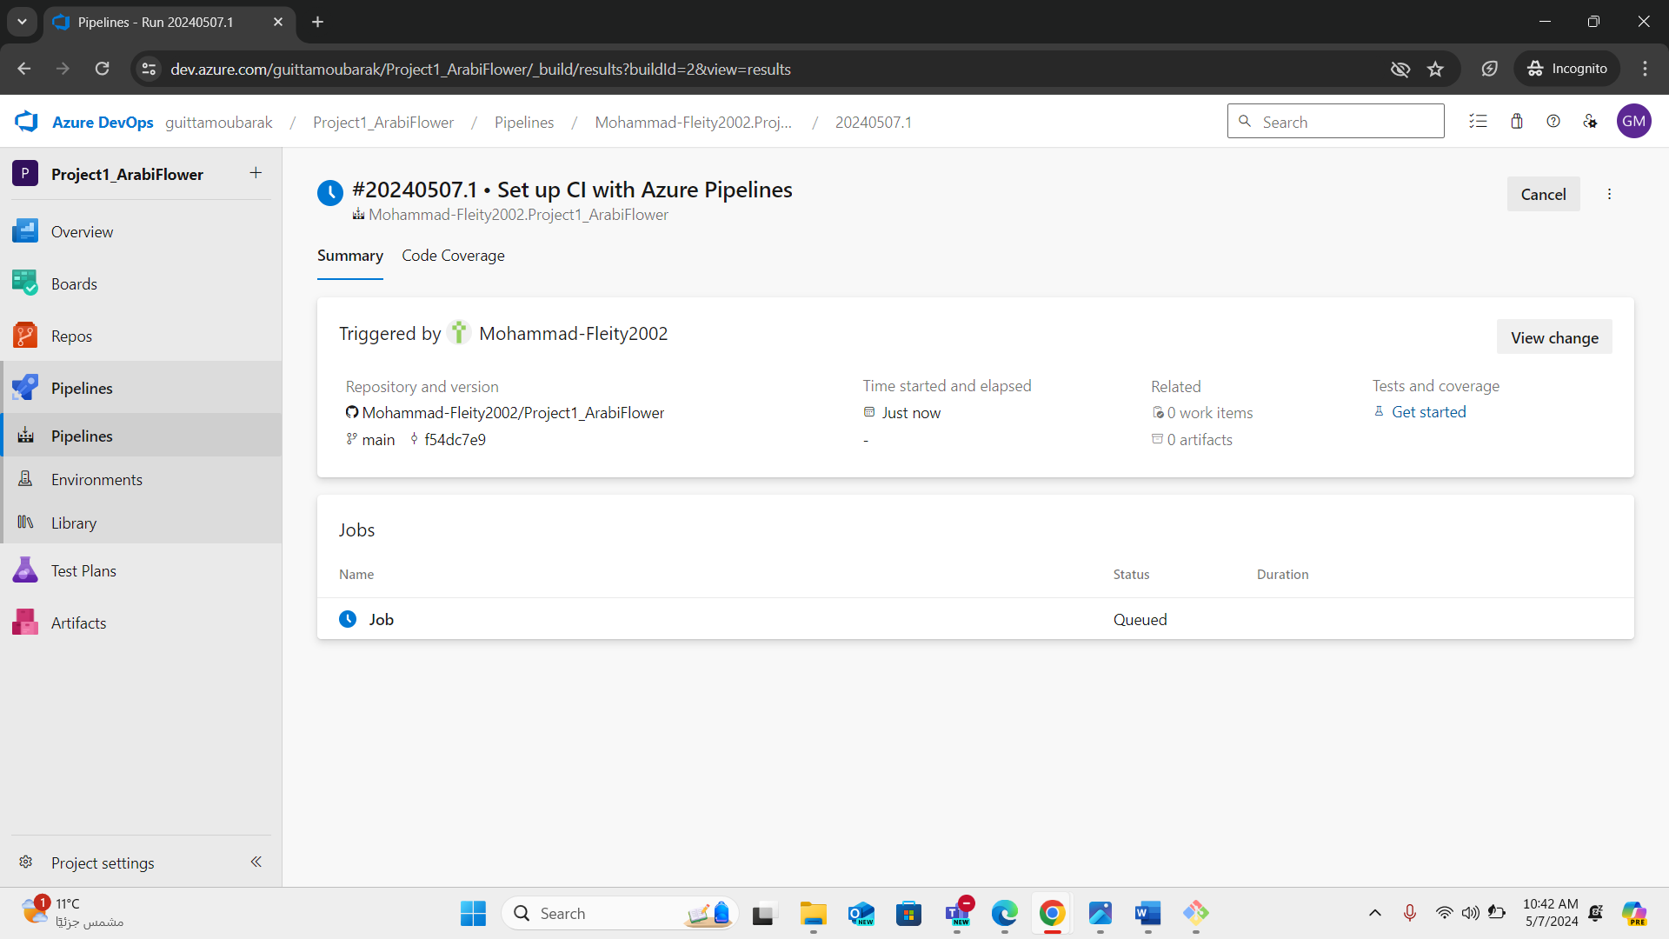

### Requesting Hosted paralleliosm:

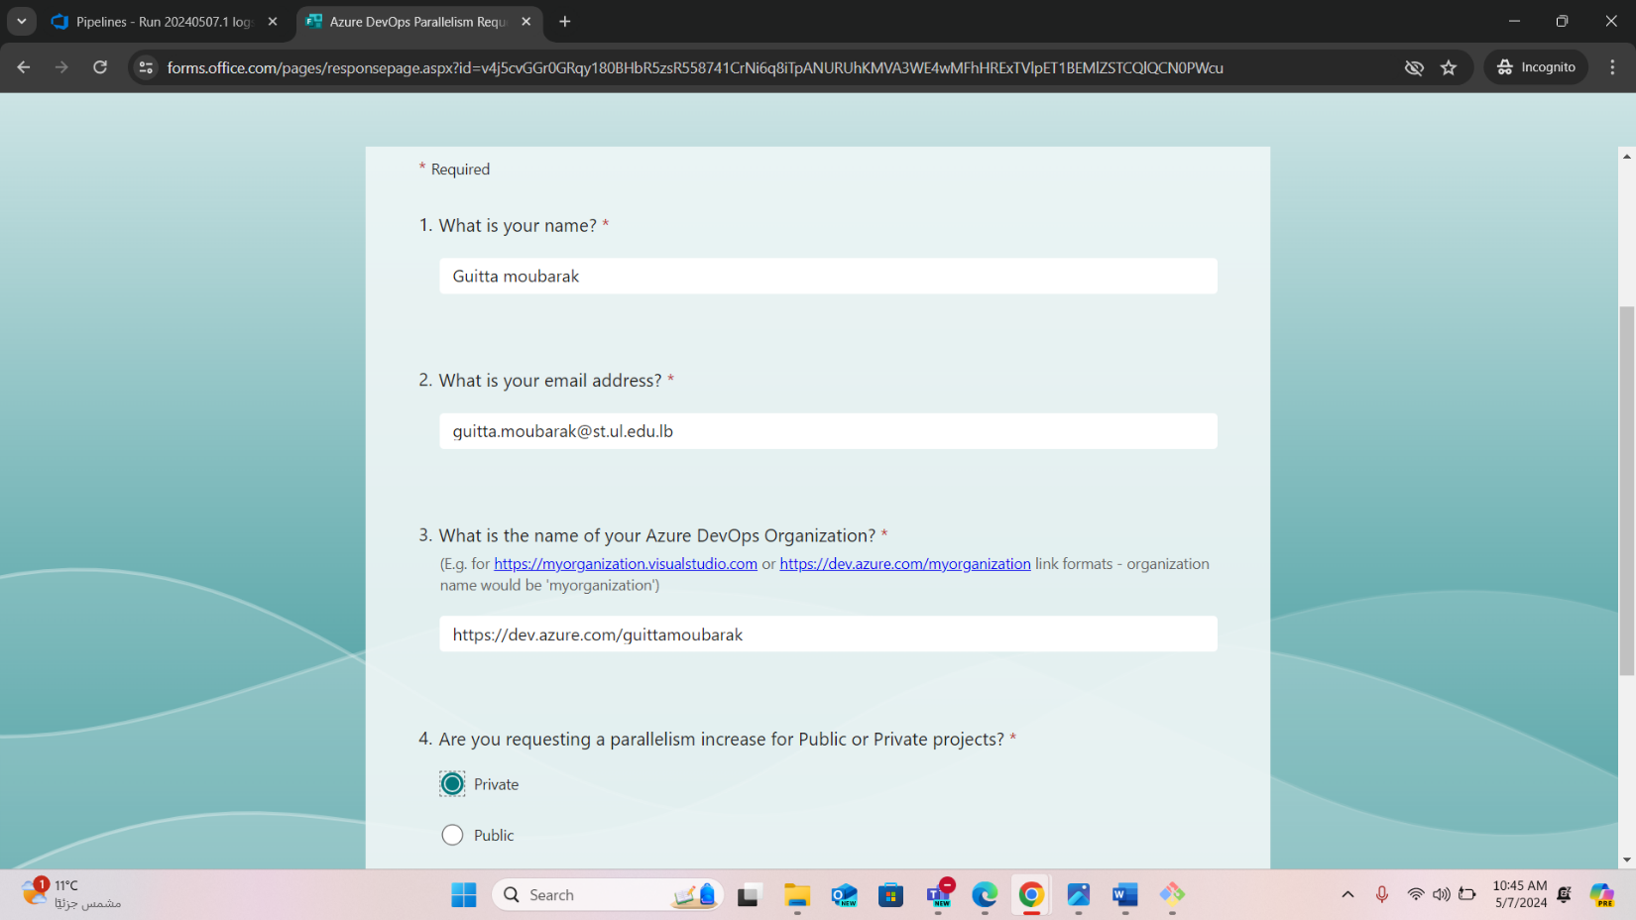

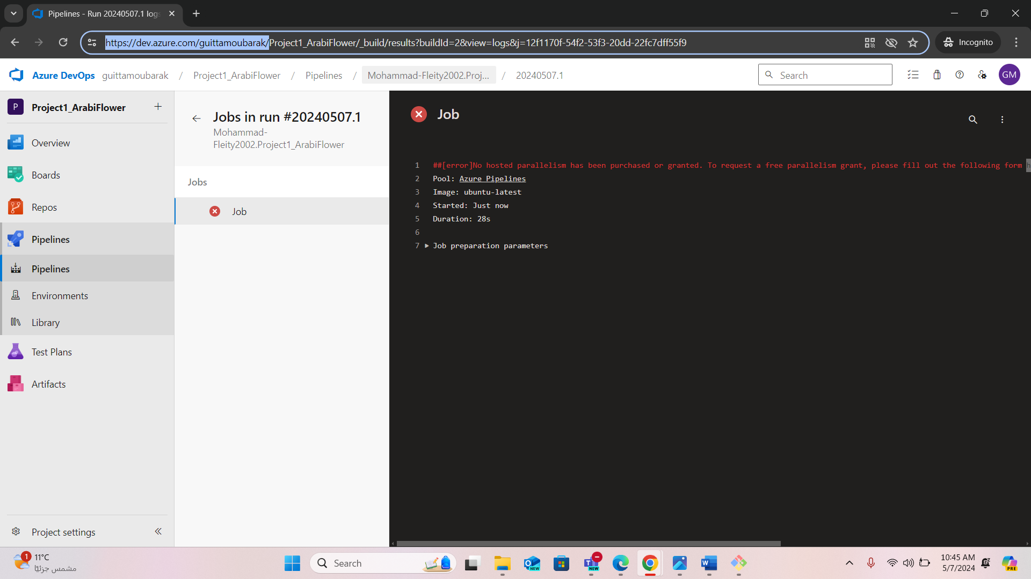

## Creating account on docker hub to store images:

=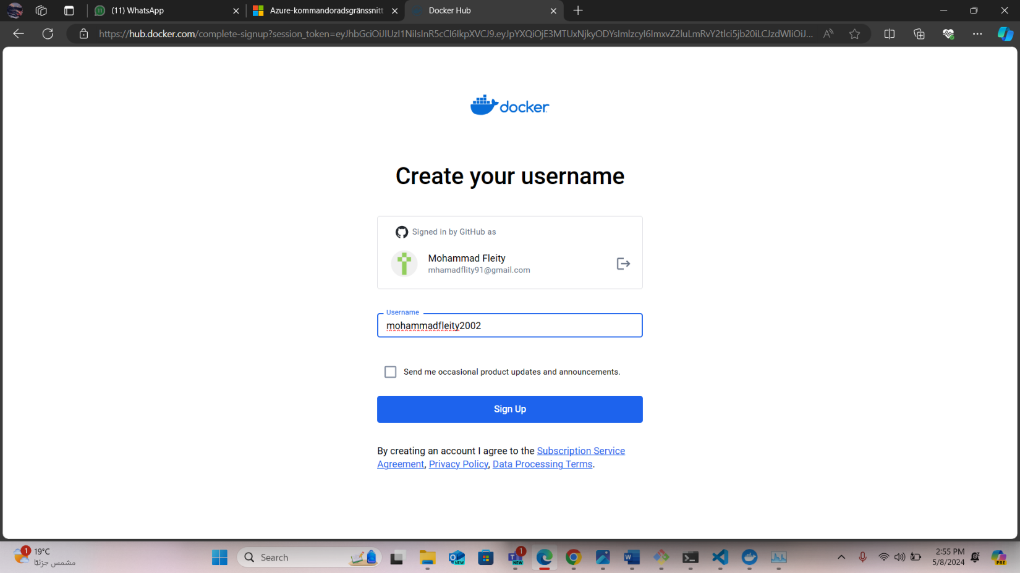

### Creating a repo on docker hub

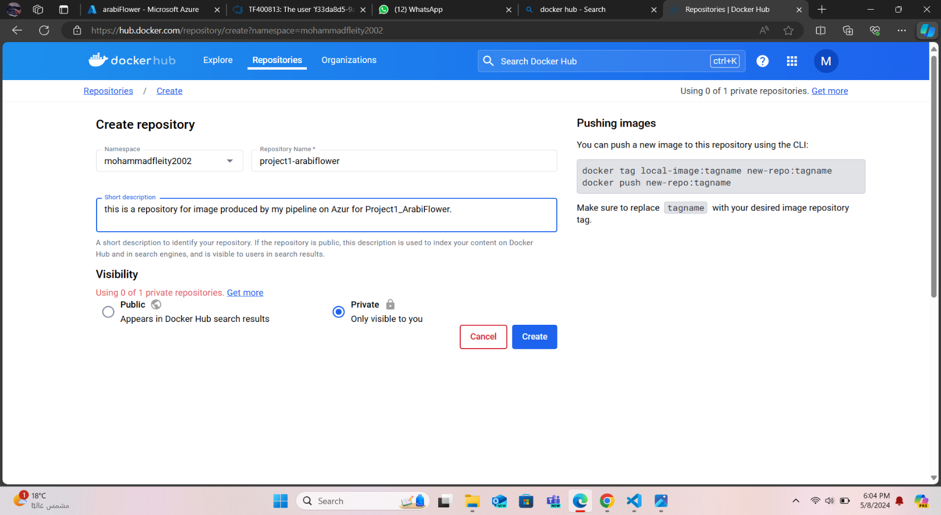

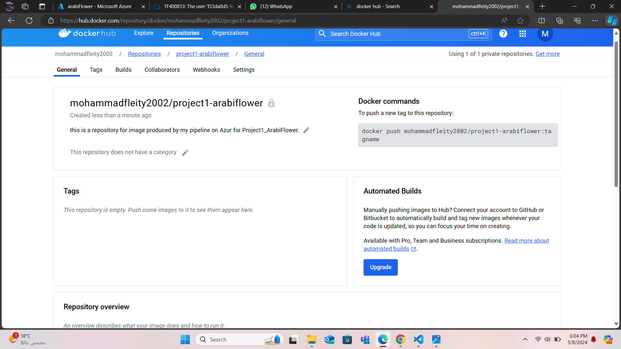

### Adding a DOCKERFILE to the repository

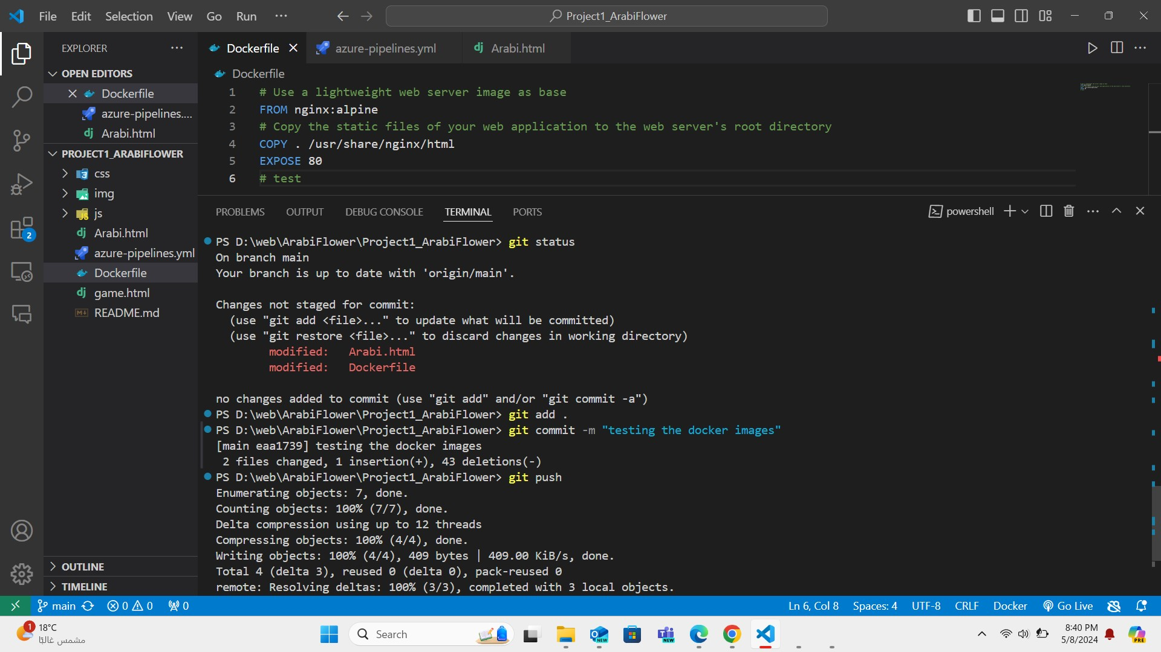

## Creating a service connection to the docker hub:

**PS:** This service connection was first created with the intention to use Azure Container Registry instead of the docker hub then it was edited later as shown below.

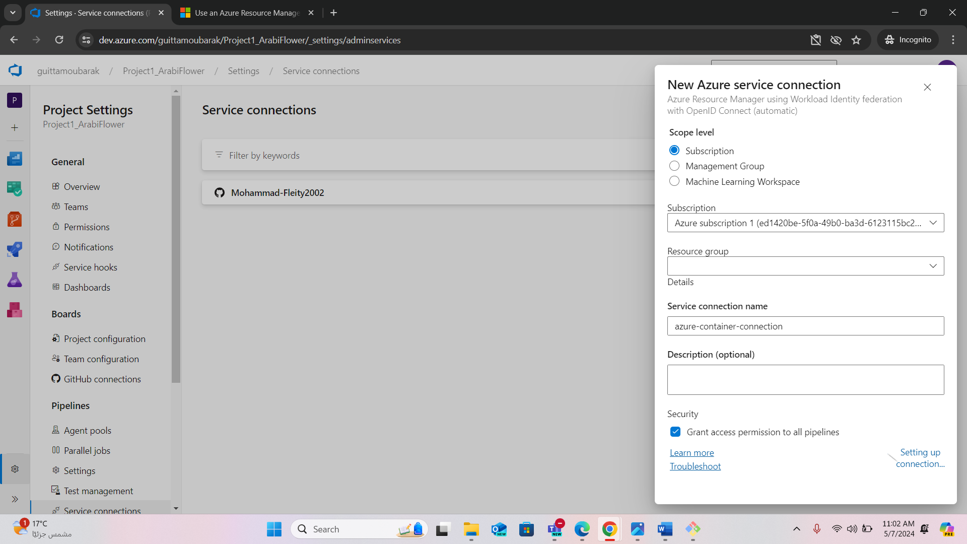

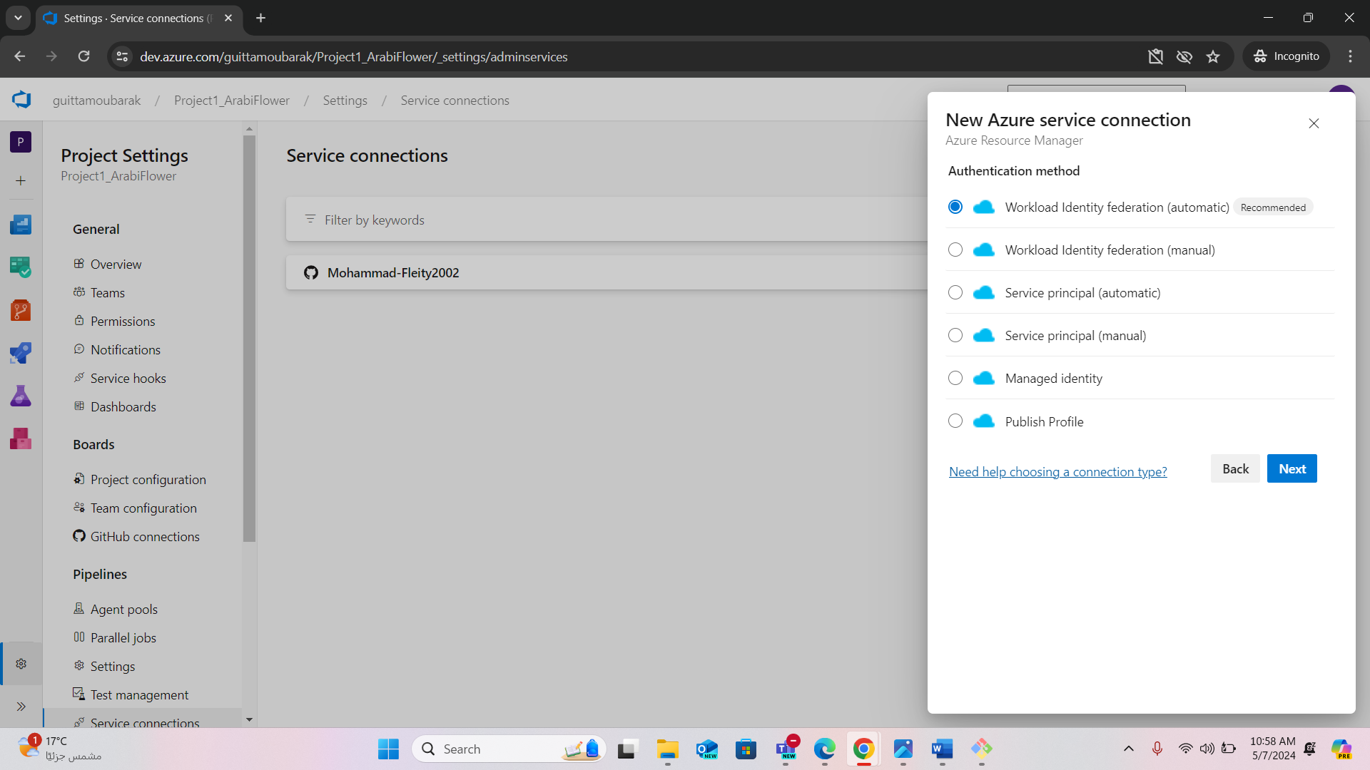

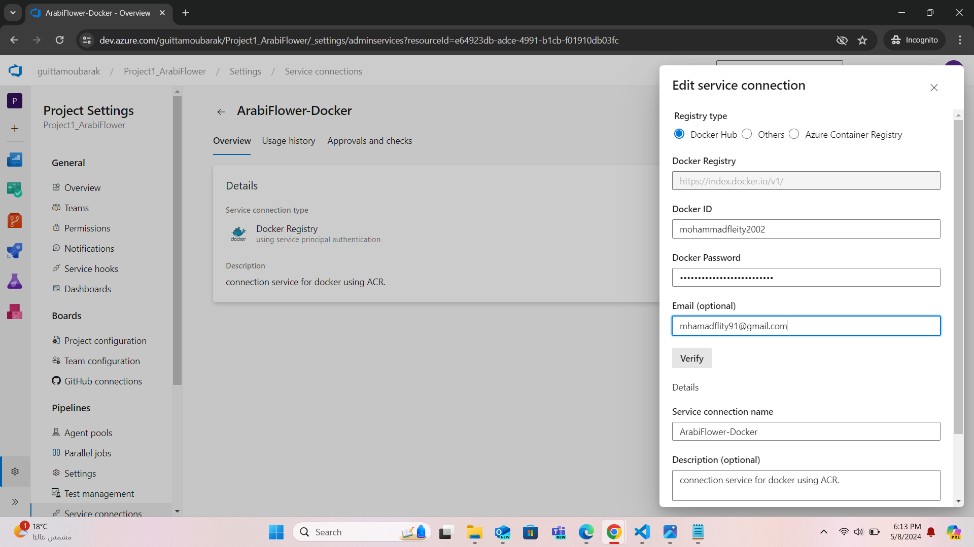

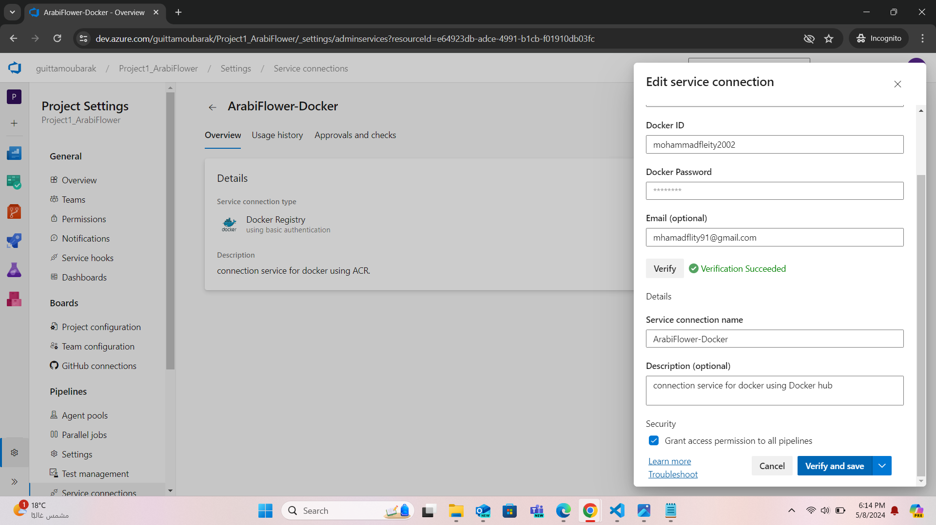

## Configuring the pipeline:

**PS:** Since this a static website css/html/js no test or building steps needed. So we’re just printing “Building App” and “Run Tests” instead.

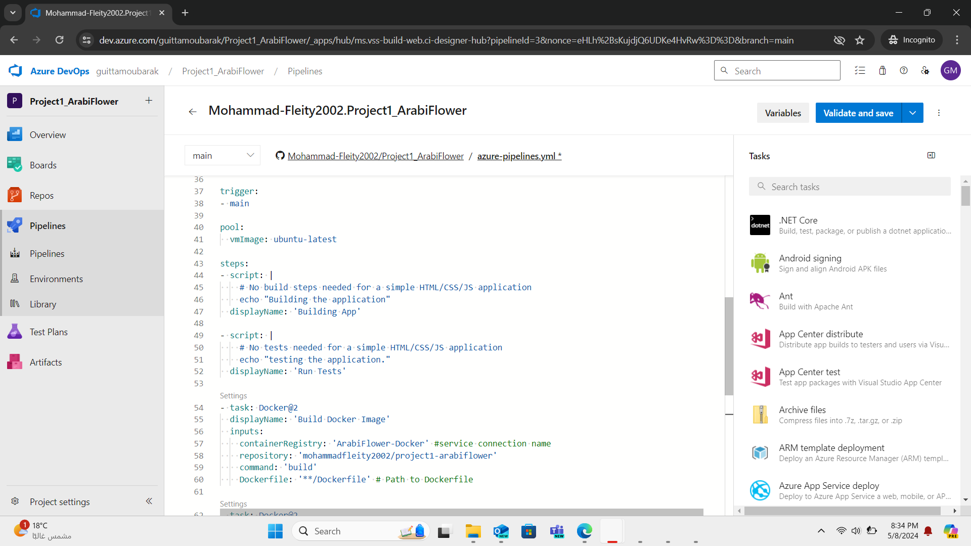

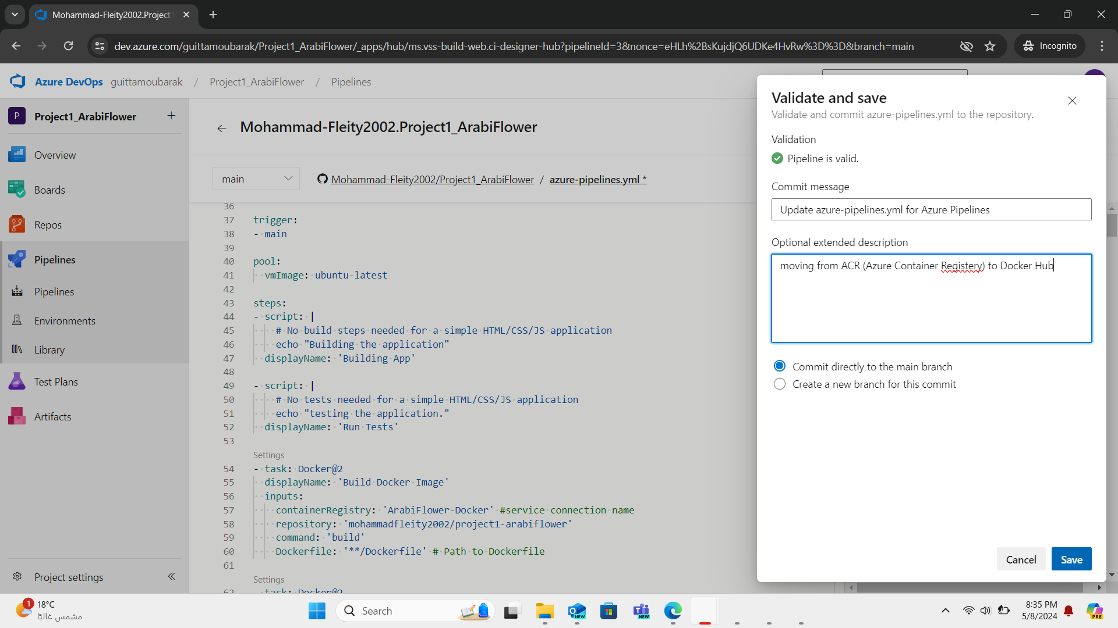

## TESTING:

### Push an update:

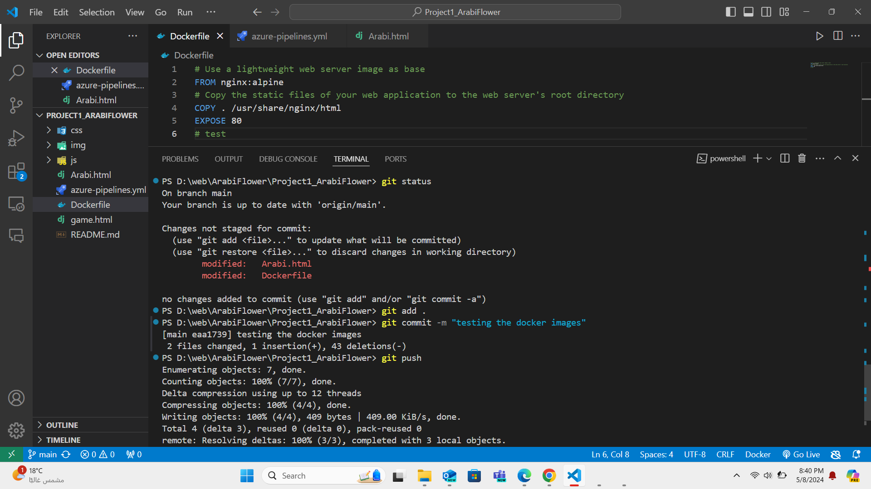

### Checking the pipeline

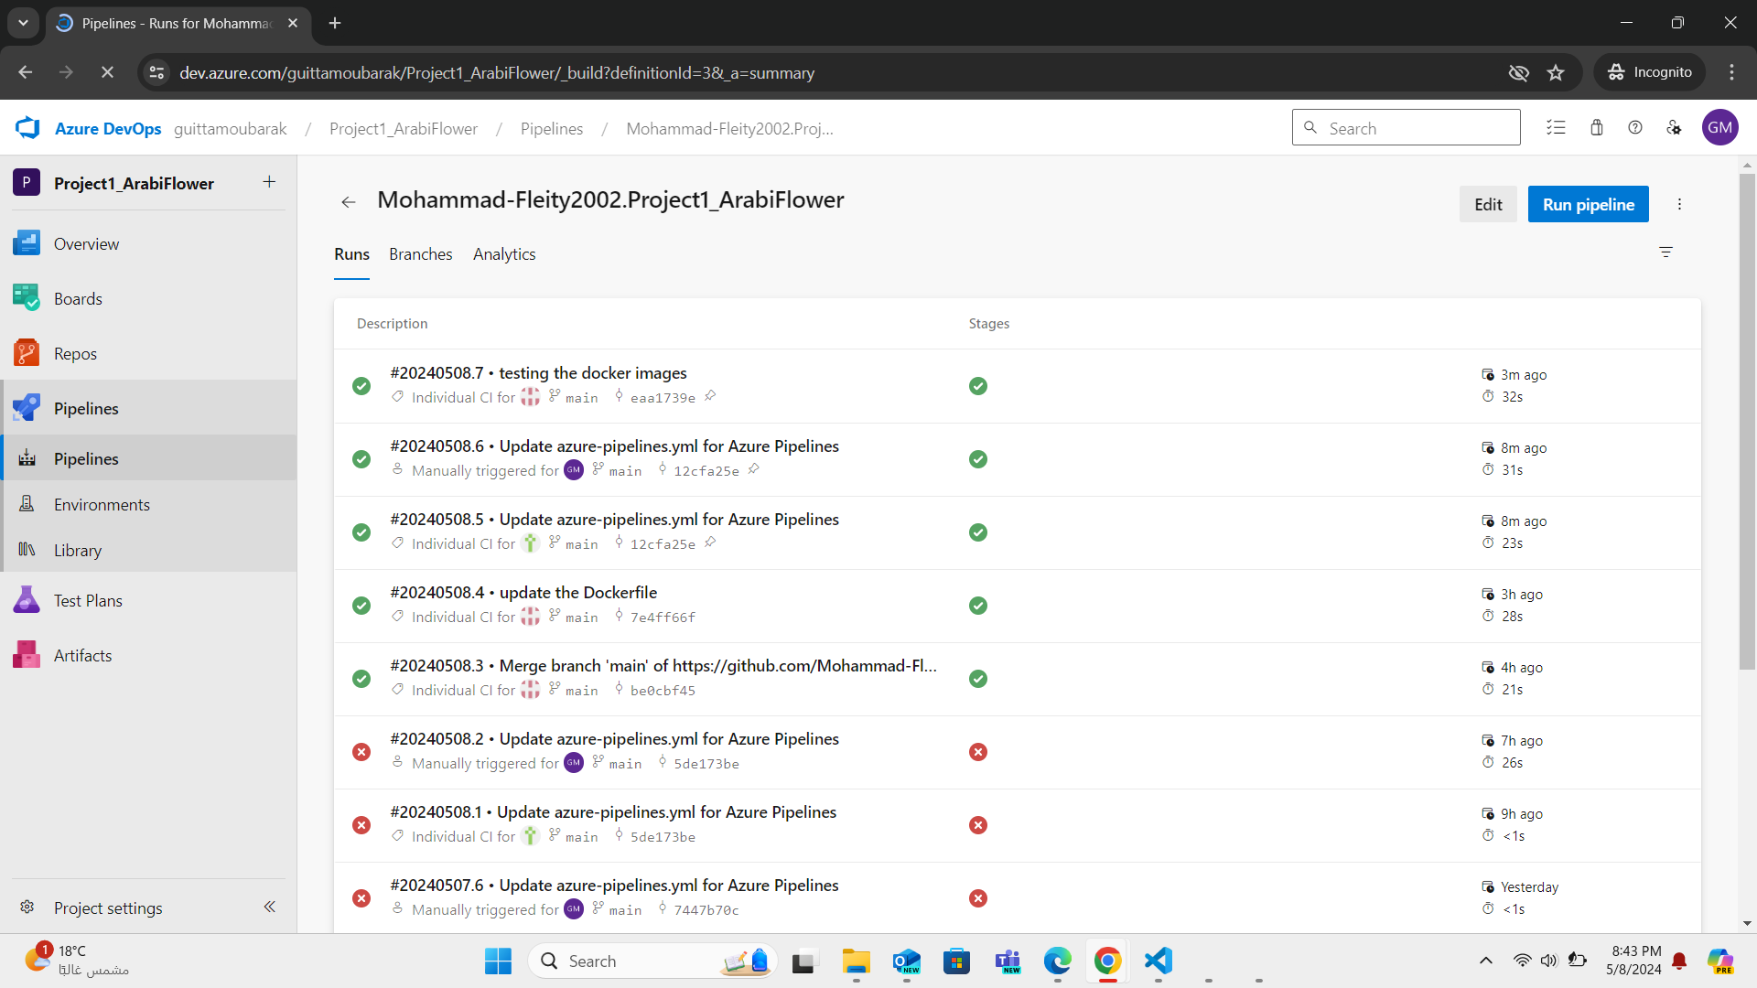

### Checking the repos on docker hub:

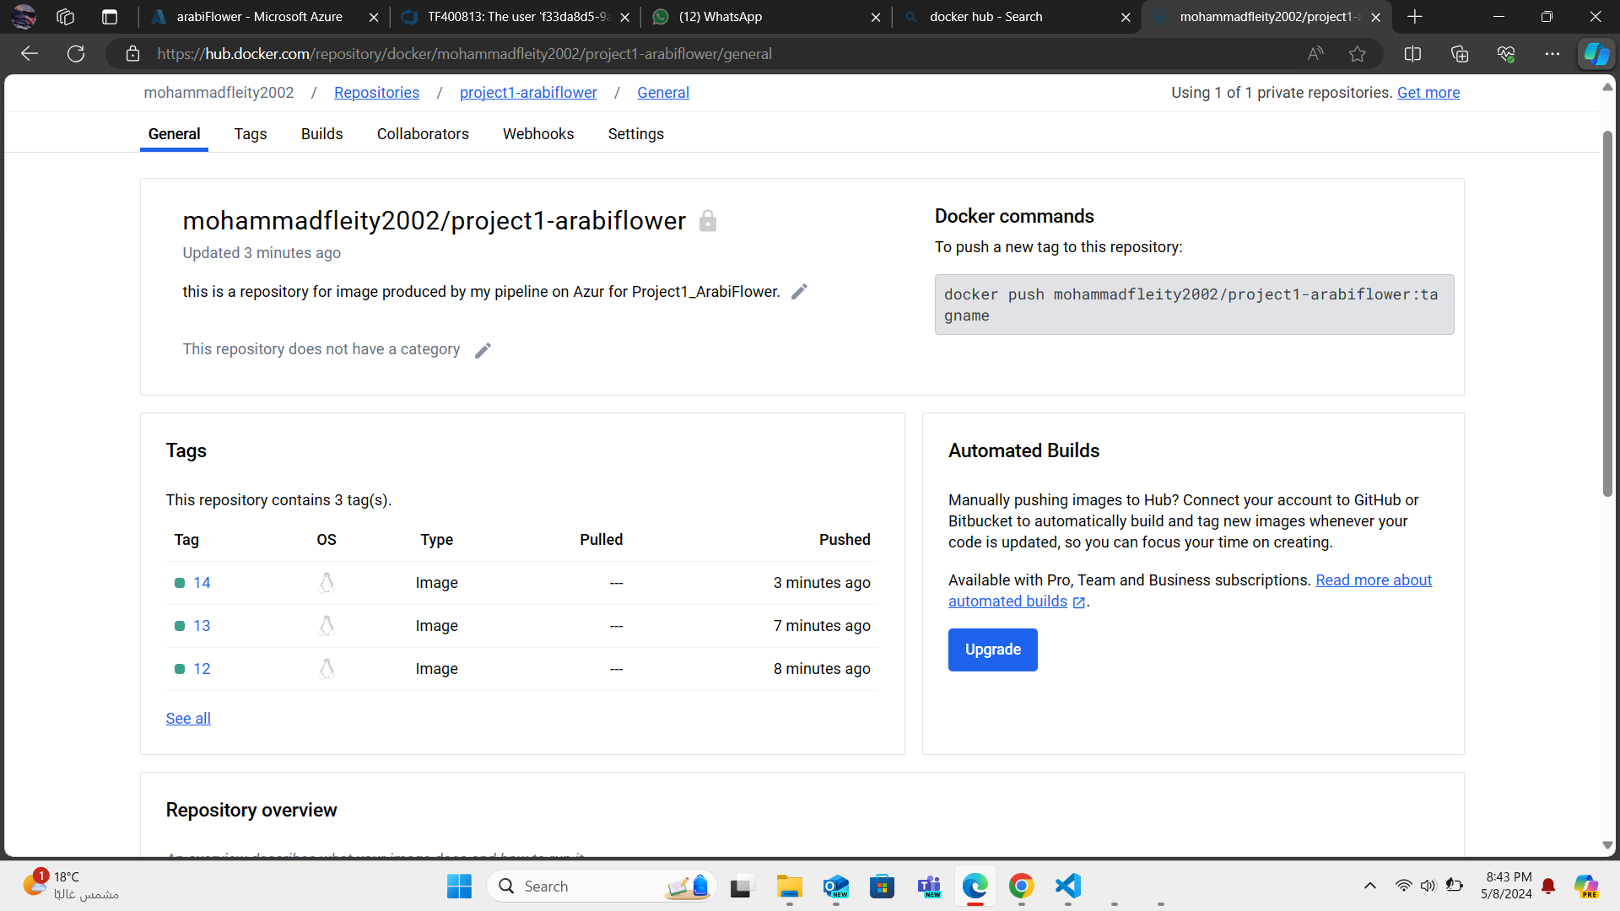

# Continuous Deployment (CD)

## Creating a WebApp resource to host the application

**PS:** The web app load from the latest image in the docker hub repository.

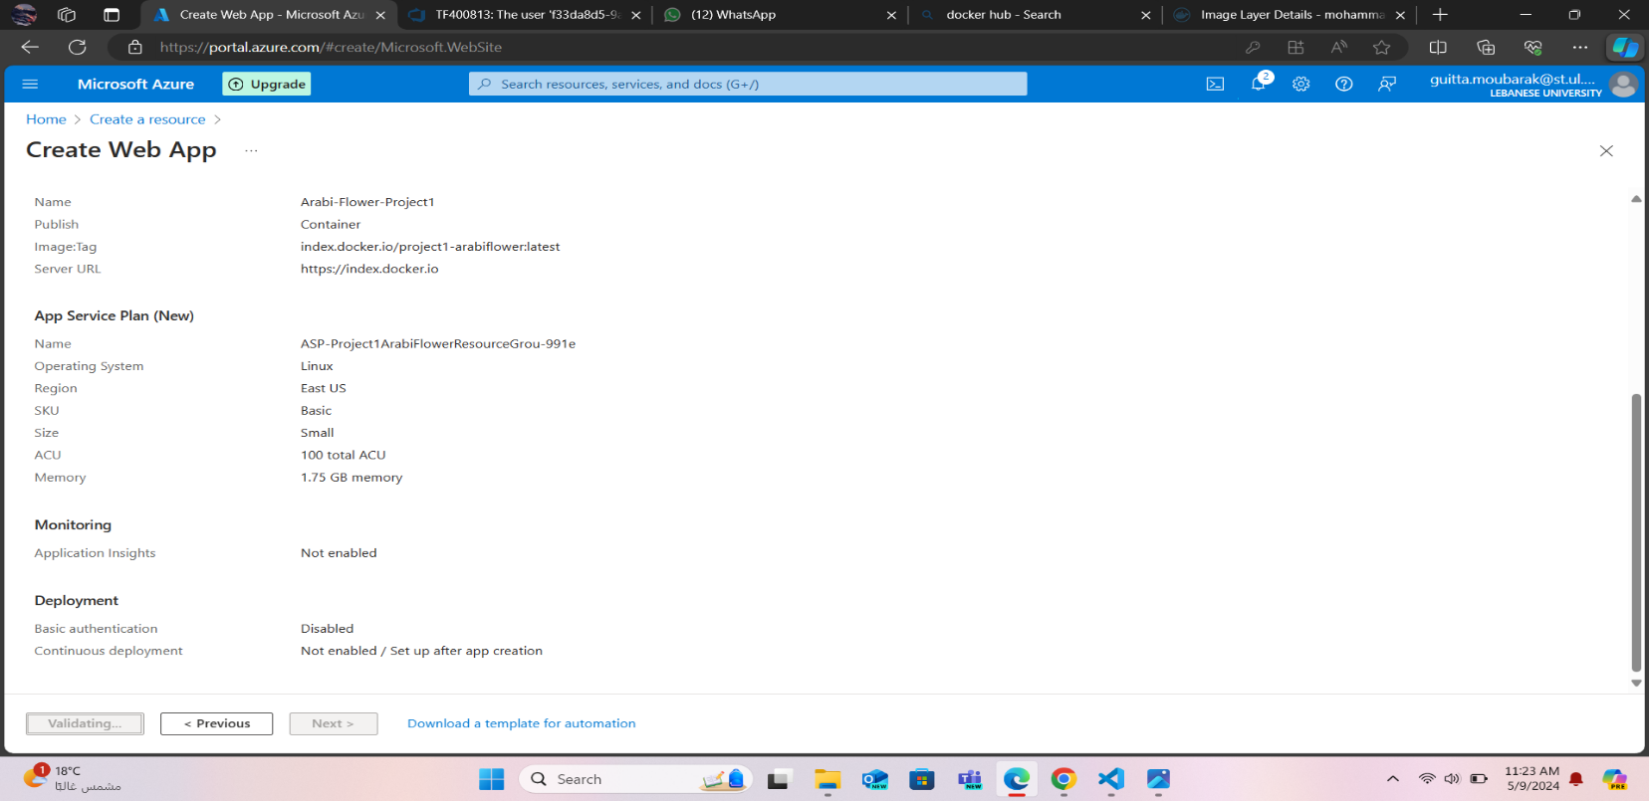

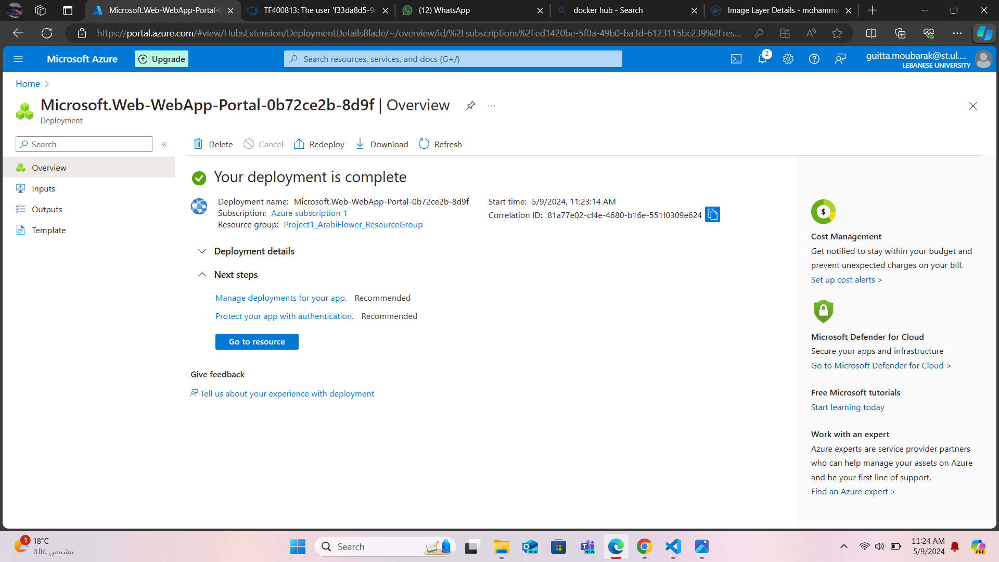

## Creating Pipeline to automate CD:

**PS:** The Project was done from 07/05/2024->09/05/2024 but the cd Pipeline Screenshots was missing this is a replacement taken on 30/05/2024 the date of creating this report.

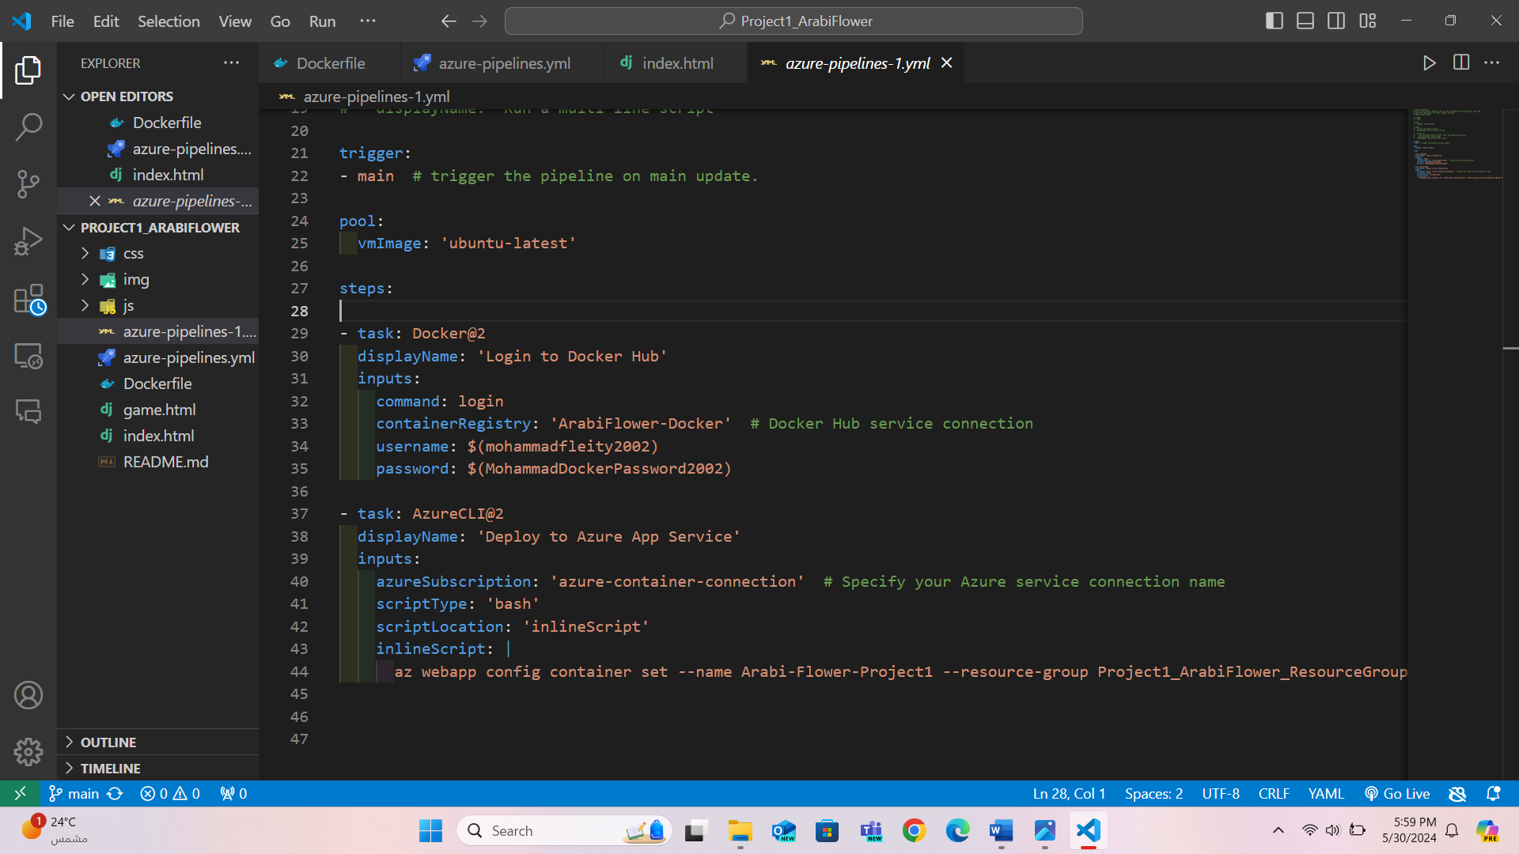

this pipeline trigger on commit on the main branch and reload the web app from the latest image on docker hub.

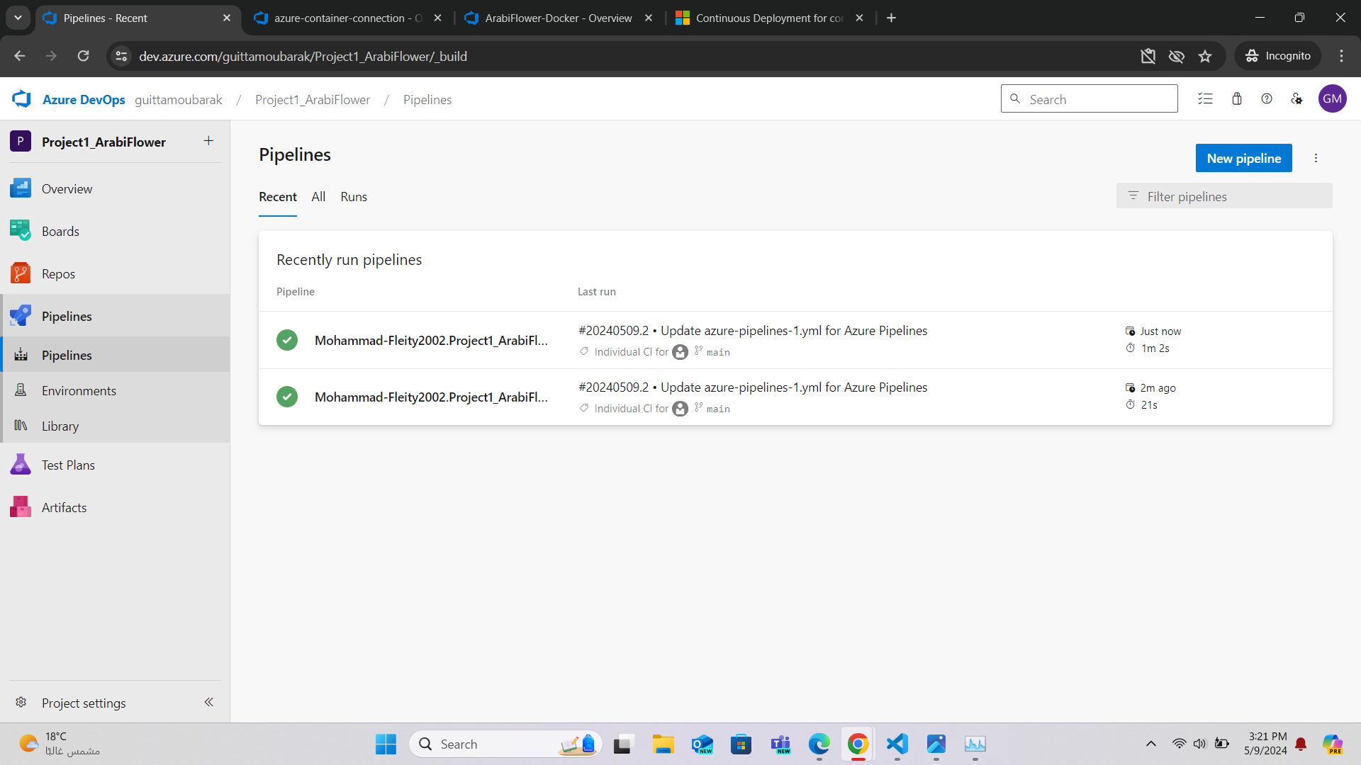



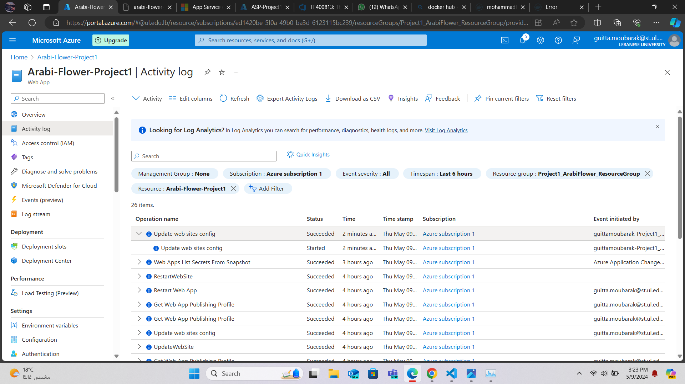

## TESTING:

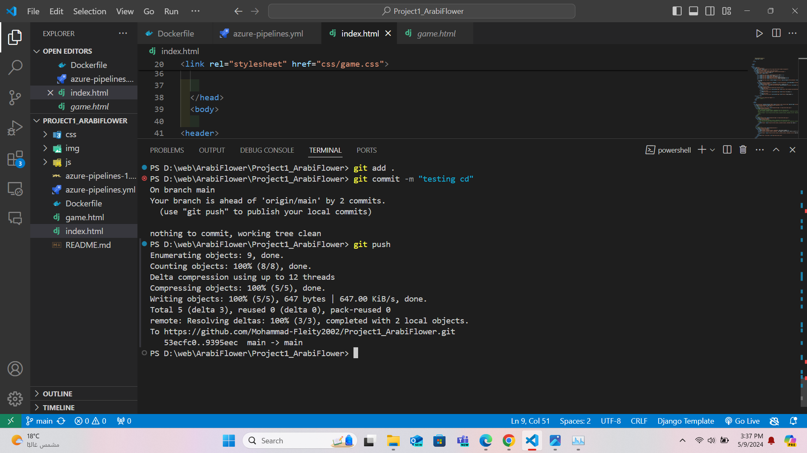

Both Pipelines were runed successfully.

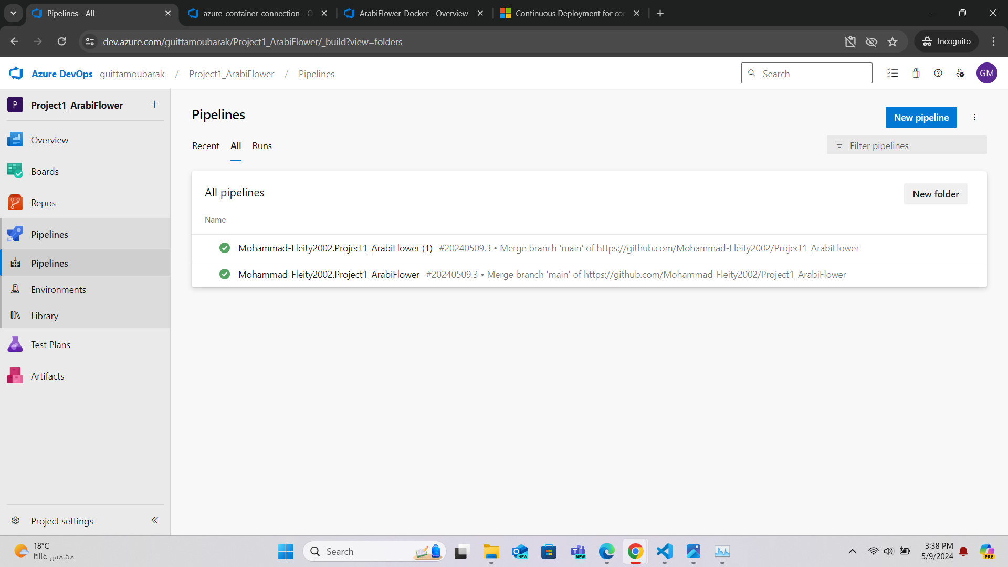

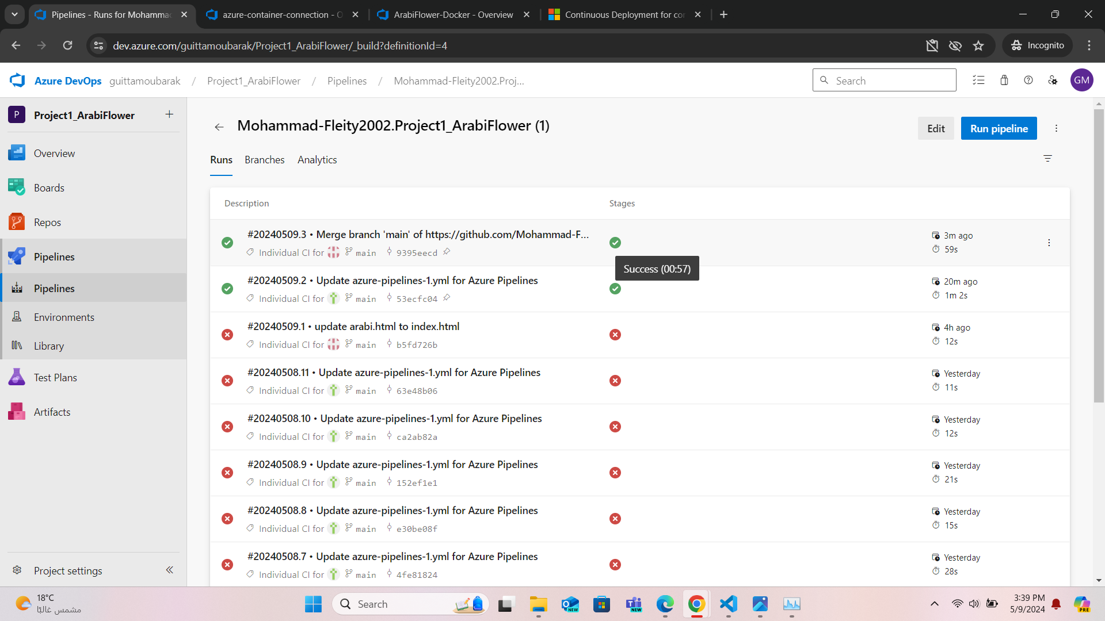

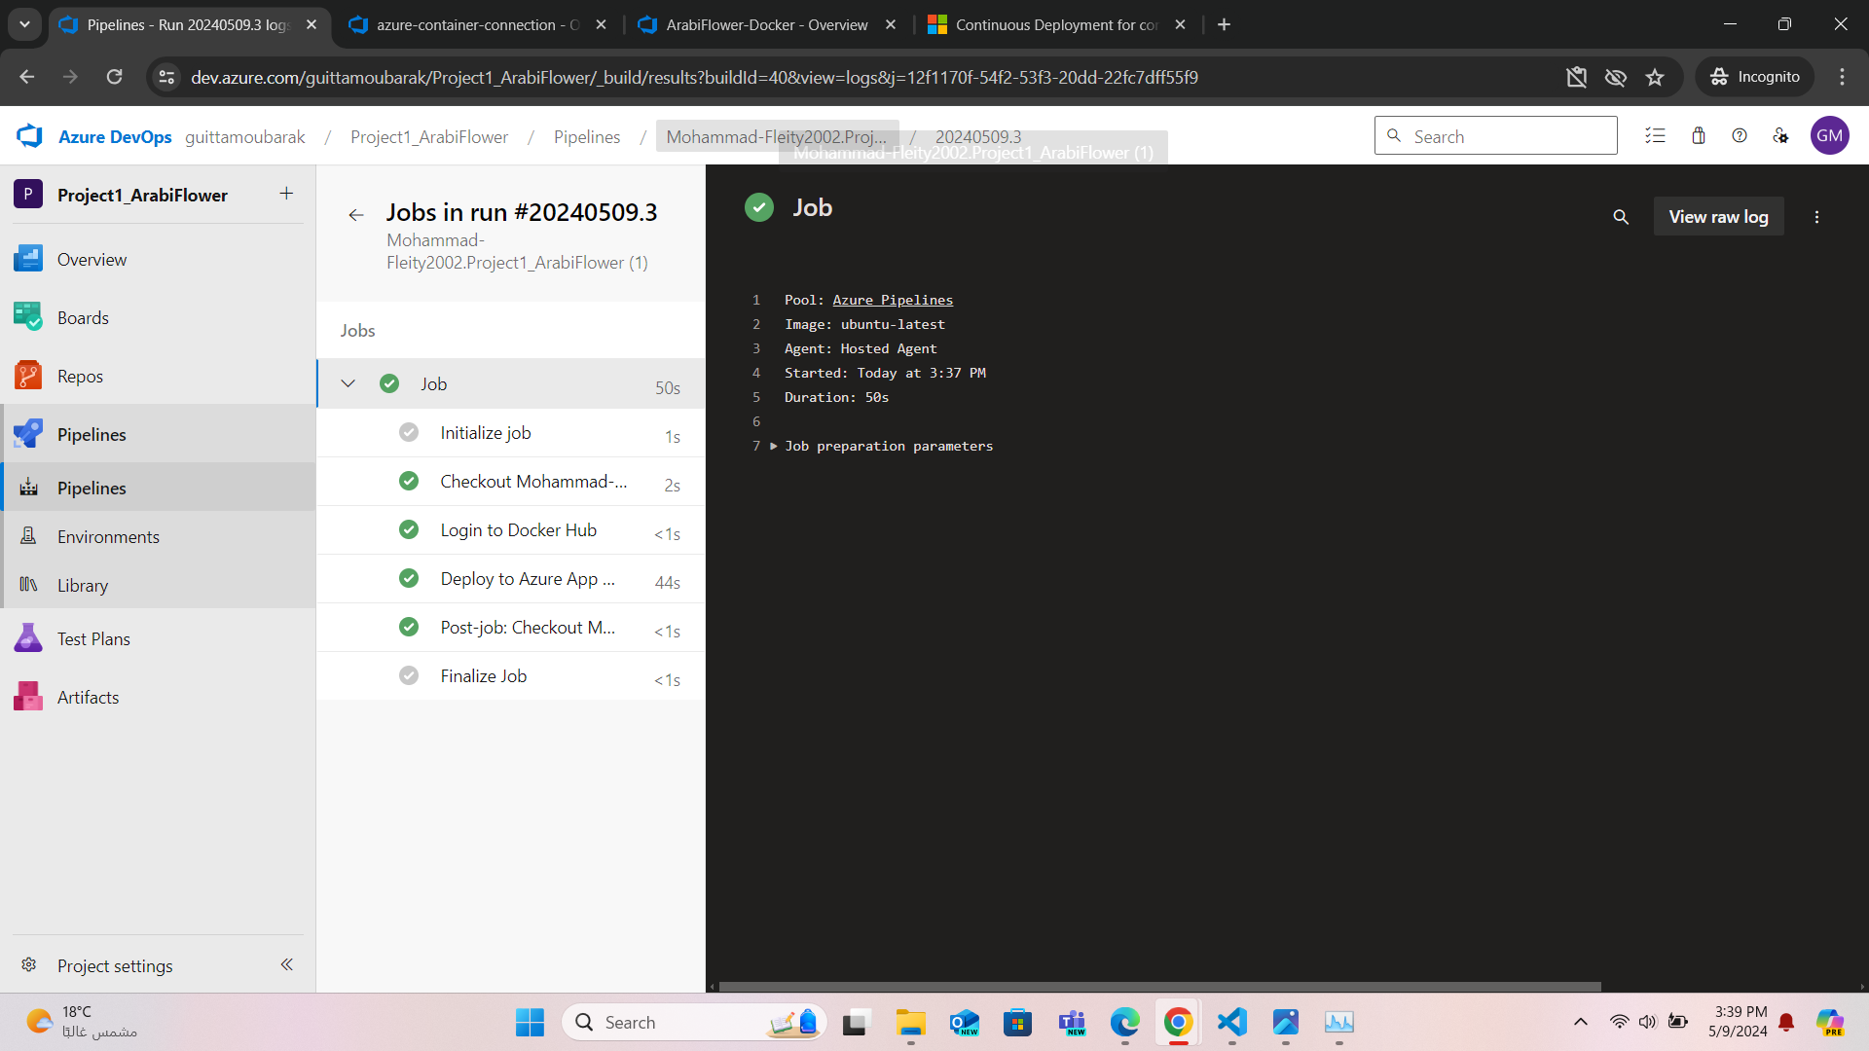

Deployment was done successfully.

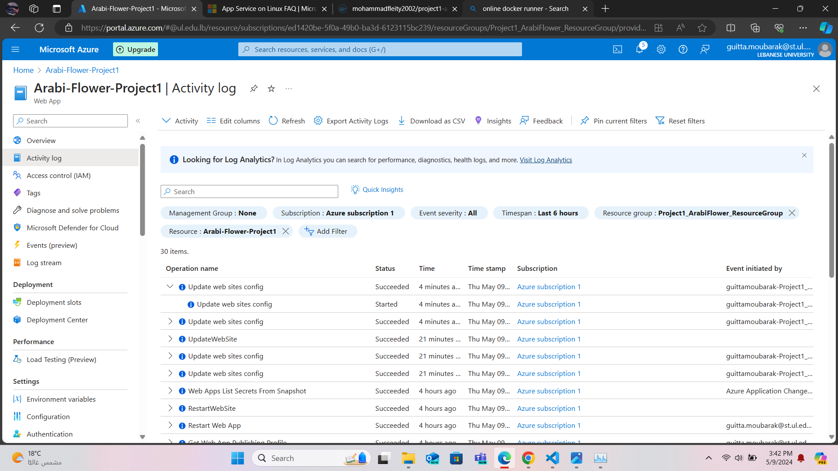

Thank You for Your Time.